 | 
COUNCIL ASSESSMENT REPORT
WESTERN REGIONAL PLANNING PANEL

PANEL REFERENCE & DA NUMBER | PPSWES-324 – DA170/25
PROPOSAL | Recreation Area (Mountain Bike Park)
ADDRESS | - Lot 1 DP965231, Coalbrook Street, Lithgow NSW 2790  - Lots 1, 2 & 3 DP1110346, Macaulay Street, Lithgow NSW 2790  - Lot 2 DP 787403 & Lot 11 DP1240259, 3A State Mine Gully Road, Lithgow NSW 2790  - Lot 10 DP1240259, 3 State Mine Gully Road, Lithgow NSW 2790 (Existing Right of Carriageway/no works proposed on this land).  - Lot 2 DP876025, Atkinson Street, Morts Estate NSW 2790
APPLICANT | SJB Planning on behalf of Central Tablelands Mountain Bike Club INC.
OWNER | - NSW Crown Land,  - Lithgow City Council,  - The City of Greater Lithgow Mining Museum Incorporated,  - Lithgow State Mine Railway Limited,  - Mr Maroun Romanous
DA LODGEMENT DATE | 20 October 2025
APPLICATION TYPE | Integrated Development Application
REGIONALLY SIGNIFICANT CRITERIA | Clause 3(b) of Schedule 6 of State Environmental Planning Policy (Planning Systems) 2021: Council related development over $5million. Council is the owner of three lots on which the development is to be carried out,
CIV | $7,212,858.00 (Including GST as per Clause 208(4)(i) of the Environmental Planning and Assessment Regulation 2021).
CLAUSE 4.6 REQUESTS | N/A.
KEY SEPP/LEP | Environmental planning instruments  In determining the development application, the following environmental planning instruments will be considered pursuant to s 4.15(1)(a)(i) of the Environmental Planning & Assessment Act 1979:  - State Environmental Planning Policy (Planning Systems) 2021,  - State Environmental Planning Policy (Biodiversity & Conservation) 2021,  - State Environmental Planning Policy (Resilience & Hazards) 2021,  - State Environmental Planning Policy (Transport and Infrastructure) 2021,  - State Environmental Planning Policy (Precincts-Regional) 2021,  - Lithgow Local Environmental Plan 2014.  Development control plan  In determining the development application, the following development control plan will be considered pursuant to s 4.15(1)(a)(iii) of the Environmental Planning & Assessment Act 1979:  - Lithgow City Development Control Plan 2021  Contributions plan  The Lithgow City Council Local Infrastructure Contributions Plan (Section 7.12) 2024-2026 applies to the development proposal.
TOTAL & UNIQUE SUBMISSIONS KEY ISSUES IN SUBMISSIONS | The development was publicly notified in accordance with the Lithgow Community Participation Plan 2020 and the provisions of Environmental Planning and Assessment Regulations 2021. The notification period was for a minimum of 28 days from 5 November 2025 to 10 December 2025.  During the notification period Council received a total of 26 unique submissions, comprising fourteen (14) objections and twelve (12 - including one petition with 447 signatures) in favour of the proposal.  The following key issues were raised in the submissions:  - Carpark Design,  - Safety,  - Privacy,  - Noise,  - Stormwater, Erosion and Land Stability,  - Property Value and Amenity,  - Bushfire Risk and Evacuation Concerns,  - Aboriginal Heritage,  - Traffic Impacts,  - Biodiversity, and  - Other Potential Impacts
DOCUMENTS SUBMITTED FOR CONSIDERATION | - Aboriginal Due Diligence Assessment Report; OzArk, dated 14 August 2025,  - Biodiversity Development Assessment Report; OzArk, dated 19 August 2025,  - Bushfire Assessment Report; Integrated Consulting, dated 20 August 2025,  - Contamination Report; Consara Contaminated Sites, dated 11 August 2025,  - Detailed Design Report; World Trail PTY LTD, dated 25 July 2025,  - Geotechnical and Mine Subsidence Assessment; RCA Australia, dated 13 August 2025,  - Carpark and Trailhead Concept; World Trail PTY LTD, August 2025,  - Operational Plan of Management; PMO 360 PTY LTD, 9 October 2025,  - Public Amenities Design Plans; Modus Australia, 25 August 2025,  - Civil Design Plans; Calare Civil, 22 August 2025,  - Site Survey Plans-Existing; PMO 360 PTY LTD, 8 August 2025,  - Site Survey Plans-Proposed; PMO 360 PTY LTD, 8 August 2025,  - Statement of Environmental Effects, SJB Planning (NSW) PTY LTD, 9 October 2025,  - Statement of Heritage Impact; OzArk, 12 August 2025,  - Stormwater Management Plan; Calare Civil, 22 August 2025,  - Traffic Impact and Parking Assessment Study; Traffic Engineering Centre, 12 August 2025.
SPECIAL INFRASTRUCTURE CONTRIBUTIONS (S7.24) | The site is not located in an area that Special Infrastructure Contributions (SIC) apply.
RECOMMENDATION | Approval subject to conditions of consent
DRAFT CONDITIONS TO APPLICANT | Yes, 20 May 2026
SCHEDULED MEETING DATE | 7 July 2026
PREPARED BY | Lauren Stevens-Development Planner; Lithgow Council
DATE OF REPORT | 23 June 2026

EXECUTIVE SUMMARY
SJB Planning on behalf of Central Tablelands Mountain Bike Club INC. (the Applicant) lodged a development application (DA170/25) for the development of a Recreation Area (Mountain Bike Park) on the following parcels of land:

- Lot 1 DP965231, Coalbrook Street, Lithgow NSW 2790,
- Lots 1, 2 & 3 DP1110346, Macaulay Street, Lithgow NSW 2790,
- Lot 2 DP 787403 & Lot 11 DP1240259, 3A State Mine Gully Road, Lithgow NSW 2790,
- Lot 10 DP1240259, 3 State Mine Gully Road, Lithgow NSW 2790 (existing right of carriageway/no works proposed on this land) and
- Lot 2 DP876025, Atkinson Street, Morts Estate NSW 2790.

The development comprises the following components:

- Construction of approximately 24.54km of mountain bike trails, including one shared mountain bike/walking trail
- Ancillary Facilities:
- Trail Heads,
- Car Park for approximately 111 vehicles and associated driveway,
- Mountain Bike amenities/public toilets, picnic tables and benches,
- Retaining walls, paths, bollards and associated landscaping and fencing,
- Associated signage (directional signage/trail maps/trail markers) and
- Shuttle bus services.

The primary trailhead is proposed to be located at the State Mine Heritage Park, adjacent to the museum.

The site is located in the C3 – Environmental Management zone pursuant to Clause 2.2 of the Lithgow Local Environmental Plan 2014 (Lithgow LEP). Recreation areas are permissible with consent in the C3 zone.

The principle local planning controls relevant to the proposal include the Lithgow LEP and the Lithgow Development Control Plan 2021 (Lithgow DCP). The proposal is generally consistent with the applicable controls and standards and no departures have been identified.

The development is ‘integrated development’ under section 4.46 of the Environmental Planning and Assessment Act 1979 (EP&A Act), requiring approvals from relevant authorities pursuant to section 90 of the Water Management Act 2000 and section 22 of the Coal Mine Compensation Act 2017.

The development also triggers agency referrals and concurrence by virtue of section 4.13 of the EP&A Act 1979. Concurrence authorities are Water NSW and Endeavour Energy.

The development application was referred to Crown Lands, National Parks and Wildlife Service, State Forest, NSW Rural Fire Service and NSW Police in their capacity as neighbouring or property owners, or general notification referrals for comment/advice.
The application was placed on public exhibition from 5 November 2025 to 10 December 2025, with 26 submissions received (14 objecting and 12 in support (including one petition with 447 signatures). The submissions raised the following issues:

- Carpark Design,
- Safety,
- Privacy,
- Noise,
- Stormwater, Erosion and Land Stability,
- Property Value and Amenity,
- Bushfire Risk and Evacuation Concerns,
- Aboriginal Heritage,
- Traffic Impacts,
- Biodiversity, and
- Other Potential Impacts

These issues are considered further in this report.

Following a detailed assessment of the proposal, pursuant to Section 4.16(1)(b) of the EP&A Act, DA170/25 is recommended for approval subject to conditions contained at Attachment A of this report.

- THE SITE AND LOCALITY

  - The Site
The development comprises numerous parcels of land within the State Mine Gully area. The development involves the following parcels:

- Lot 1 DP965231, Coalbrook Street, Lithgow NSW 2790,
- Lots 1, 2 & 3 DP1110346, Macaulay Street, Lithgow NSW 2790,
- Lot 2 DP 787403 & Lot 11 DP1240259, 3A State Mine Gully Road, Lithgow NSW 2790,
- Lot 10 DP1240259, 3 State Mine Gully Road, Lithgow NSW 2790 (existing right of carriageway/no works proposed on this land) and
- Lot 2 DP876025, Atkinson Street, Morts Estate NSW 2790. The DA only seeks consent for works on part of Lot 2 DP876025 located on the western side of State Mine Gully Road.
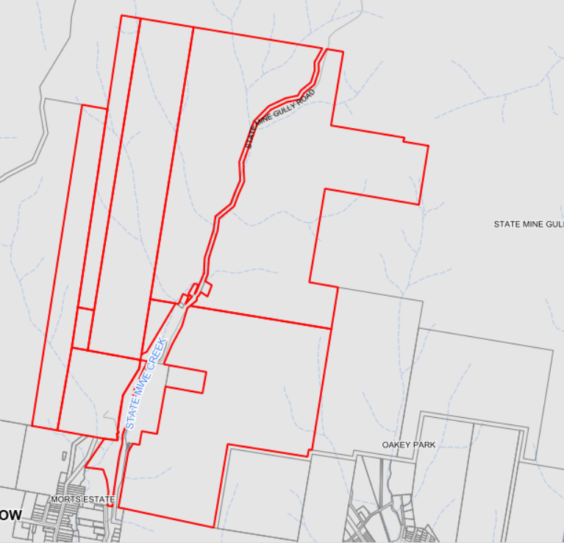
Lot 10 DP1240259
State Mine Railway Pty
Lot 3 DP1110346
Council
Lot 2 DP1110346
Council
Lot 1 DP1110346
Council
Lot 1 DP965231
Crown
Lot 2 DP787403
Mining Museum
Lot 2 DP876025
Private Landholder
Lot 11
DP1240259
Mining Museum
Plan 1: Locality and landownership plan

The topography of the land consists of a valley with heavily vegetated slopes and ridges both to the east and west, interspersed by diverse geological formations such as rocky plateaus and sandstone pagodas. The valley further consists of native flora and fauna, ranging from eucalyptus forests to riparian zones.

The State Mine Gully precinct is currently utilised for conservation (specifically Gardens of Stone Conservation Area) and recreation activities, involving scenic views and the opportunity for visitors to explore the industrial history and topography of the mountain ranges, Newnes Plateau Landscape and valleys that make up the Lithgow Region.

The north boundary of the site adjoins Gardens of Stone State Conservation Area which continues to connect to the eastern site boundary. To the south of the site is Morts Estate comprising urban development. Cobar Park is situated west of the site comprising dense vegetation.
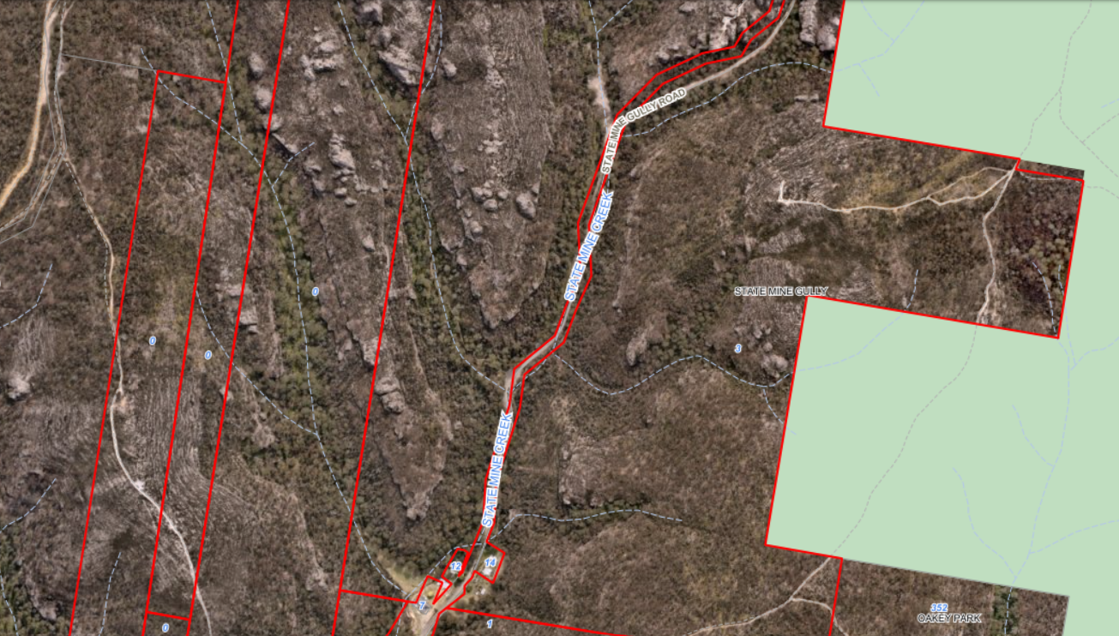
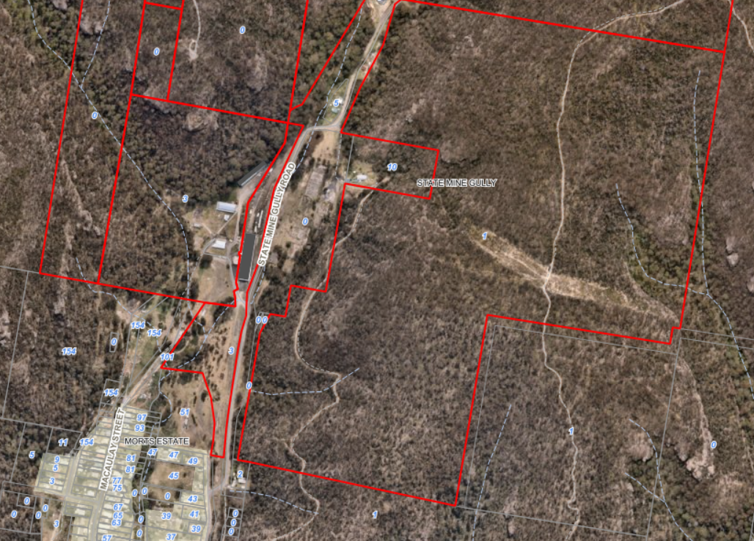
Figure 1: Aerial Image of the development site,2025

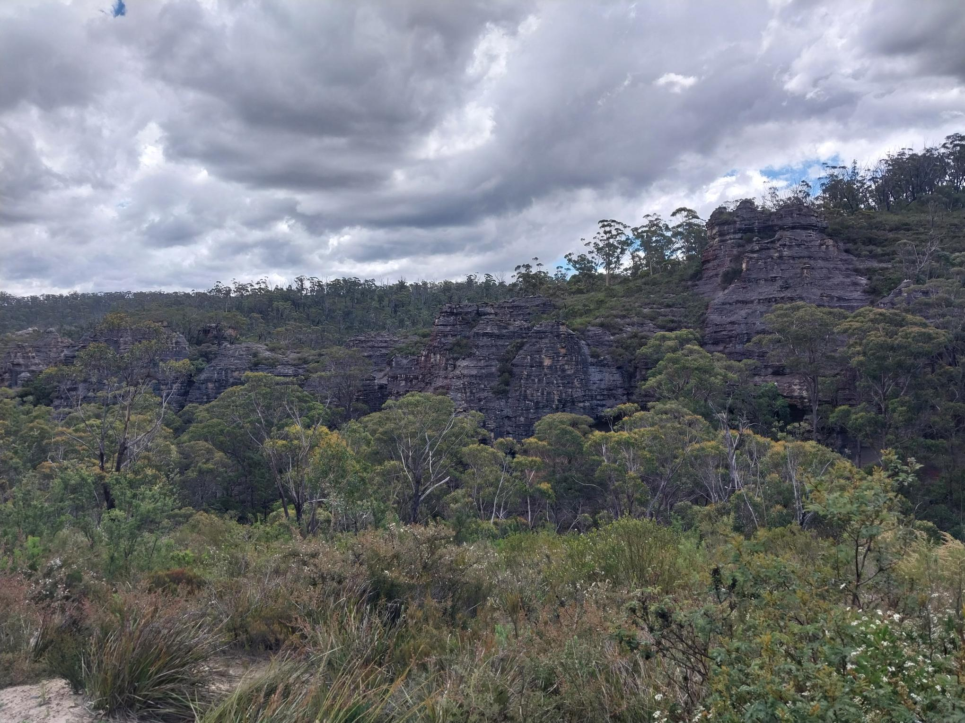
Figure 2: Photo of the pagodas within the Newnes Plateau, where the tracks are proposed beneath, 19 February 2026

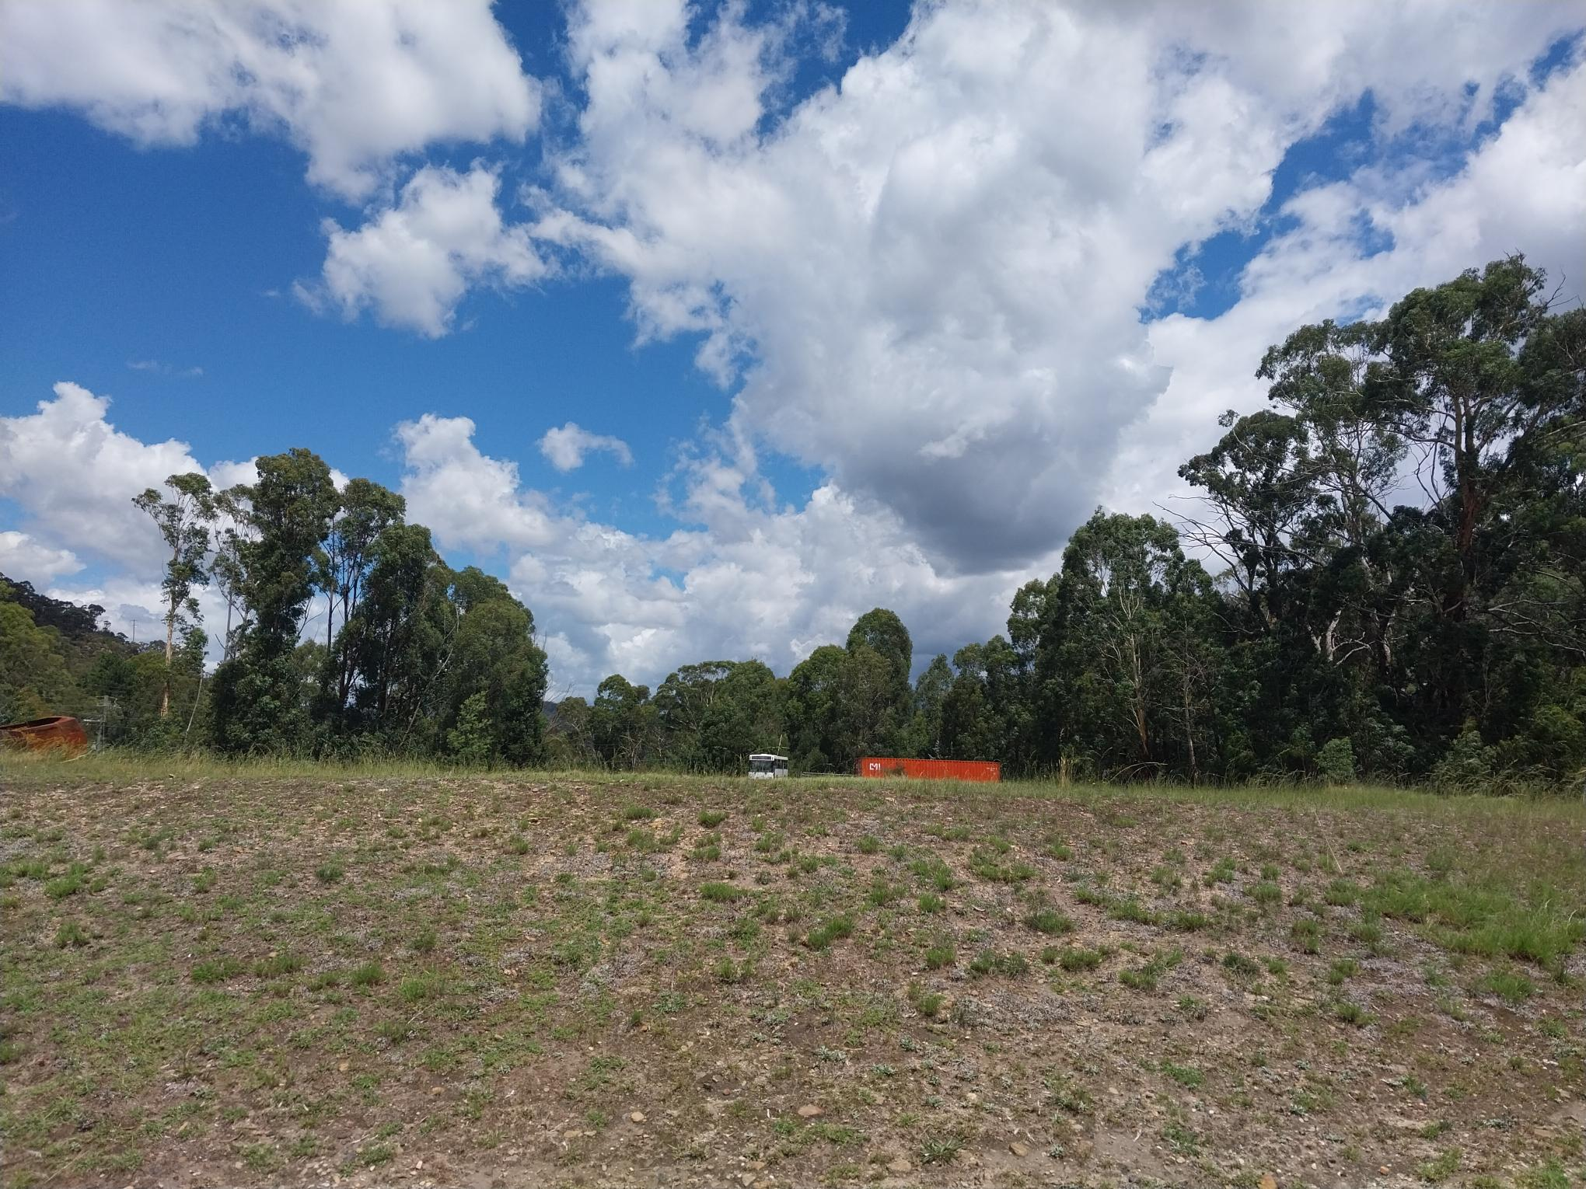
Figure 3: Photo of the proposed carpark area, 18 February 2026

  - The Locality

The site’s local context is defined by approximately 220 hectares of the State Mine Gully, centred around the Lithgow State Mine Heritage Park, approximately 3km north of the Lithgow town centre. State Mine Gully Road and State Mine Creek traverse through the centre of the site in a north-south direction towards Lithgow.

- THE PROPOSAL AND BACKGROUND

  - The Proposal

The application is seeking consent for the development of a mountain bike park comprising the following:

- Construction of approximately 24.54km of mountain bike trails, including one shared mountain bike/walking trail
- Ancillary Facilities:
- Trail Heads,
- Car Park for approximately 111 vehicles and associated driveway,
- Mountain Bike amenities/public toilets, picnic tables and benches,
- Retaining walls, paths, bollards and associated landscaping and fencing,
- Associated signage (directional signage/trail maps/trail markers) and
- Shuttle bus services.

The primary trailhead is proposed to be located at the State Mine Heritage Park, adjacent to the museum.

The purpose of the proposal is to provide recreational opportunities for residents and visitors to the area, in conjunction with the existing railway and mining museum located at State Mine Heritage Park.

Trails

The key features of the trails include:
- Twenty-two mountain bike trails, totalling 24.54 km in length;
- Eleven ‘Adventure’ trails/cross-country trails, involves a mix of climbs, descents and flats and are mostly loop trails;
- Nine ‘Flow’ trails – dedicated point-to-point descending trails with gentle to moderate gradients, bermed corners, rollers and jumps;
- One ‘Shared-use’ trail – this Easy trail is intended to be shared by walkers and riders. This forms the main climbing trail from the bottom to the top. It is intended to be dual directional for walkers, but single direction for bike riders (uphill direction only).
- One ‘Gravity’ trail – dedicated point-to-point descending trail, but generally rawer and more natural in form than a flow trail;
- The Trail Difficulty Ratings breakdown of the trail network is:
o 9 trails rated Easy;
o 3 trails rated Easy/Intermediate;
o 7 trails rated Intermediate;
o 2 trail rated Intermediate/ Difficult; and
o 1 trail rated Difficult.

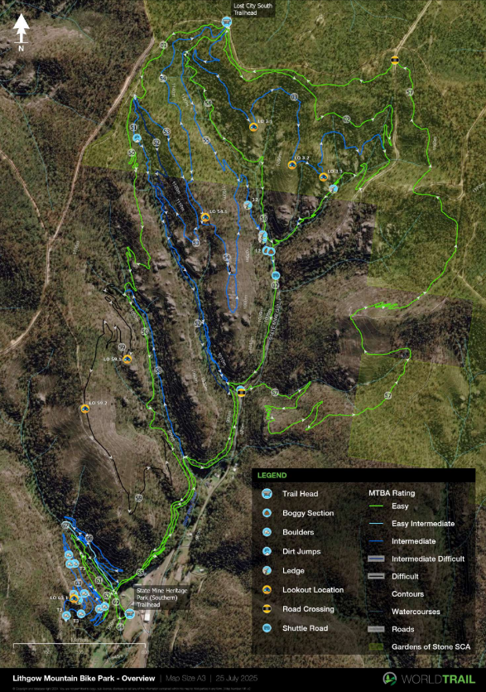
Figure 4: Proposed Tracks,

Trailheads

One primary trailhead is proposed within this project at State Mine Heritage Park. A secondary trailhead is to be provided at Lost City South. Shuttle bus services will operate between the two trailheads, with two additional shuttle pick-up points planned at key locations along State Mine Gully Road.

At the State Mine Heritage Park, a large open area just south of the museum will be converted into a car park for mountain bike riders, with the trails accessible on the western side of the car park. This trailhead will also operate as the lower shuttle pick-up point.

The Lost City South Trailhead (not part of this application) is the shuttle drop-off point for the State Mine Gully Trail Network, with all the descending trails starting from this point, and heading south into State Mine Gully. The Lost City South Trailhead is a flat area with a car parking area established by National Parks and Wildlife Service.

Construction of the trails involve the importation and installation of rock, raised boardwalks and bridges.

Materials are proposed to be transported to the trails using small ground vehicles traversing existing maintenance trails.

Carpark

The carpark is proposed to be constructed of asphalt material and is to be located on the existing cleared area known as the “chitter heap” located to the west of the existing driveway entry to the State Mine site and south of the Museum.

An Operational Management Plan provides details of the way in which the park is proposed to operate. The park is proposed to be open from sunrise to sunset, 7 days a week.

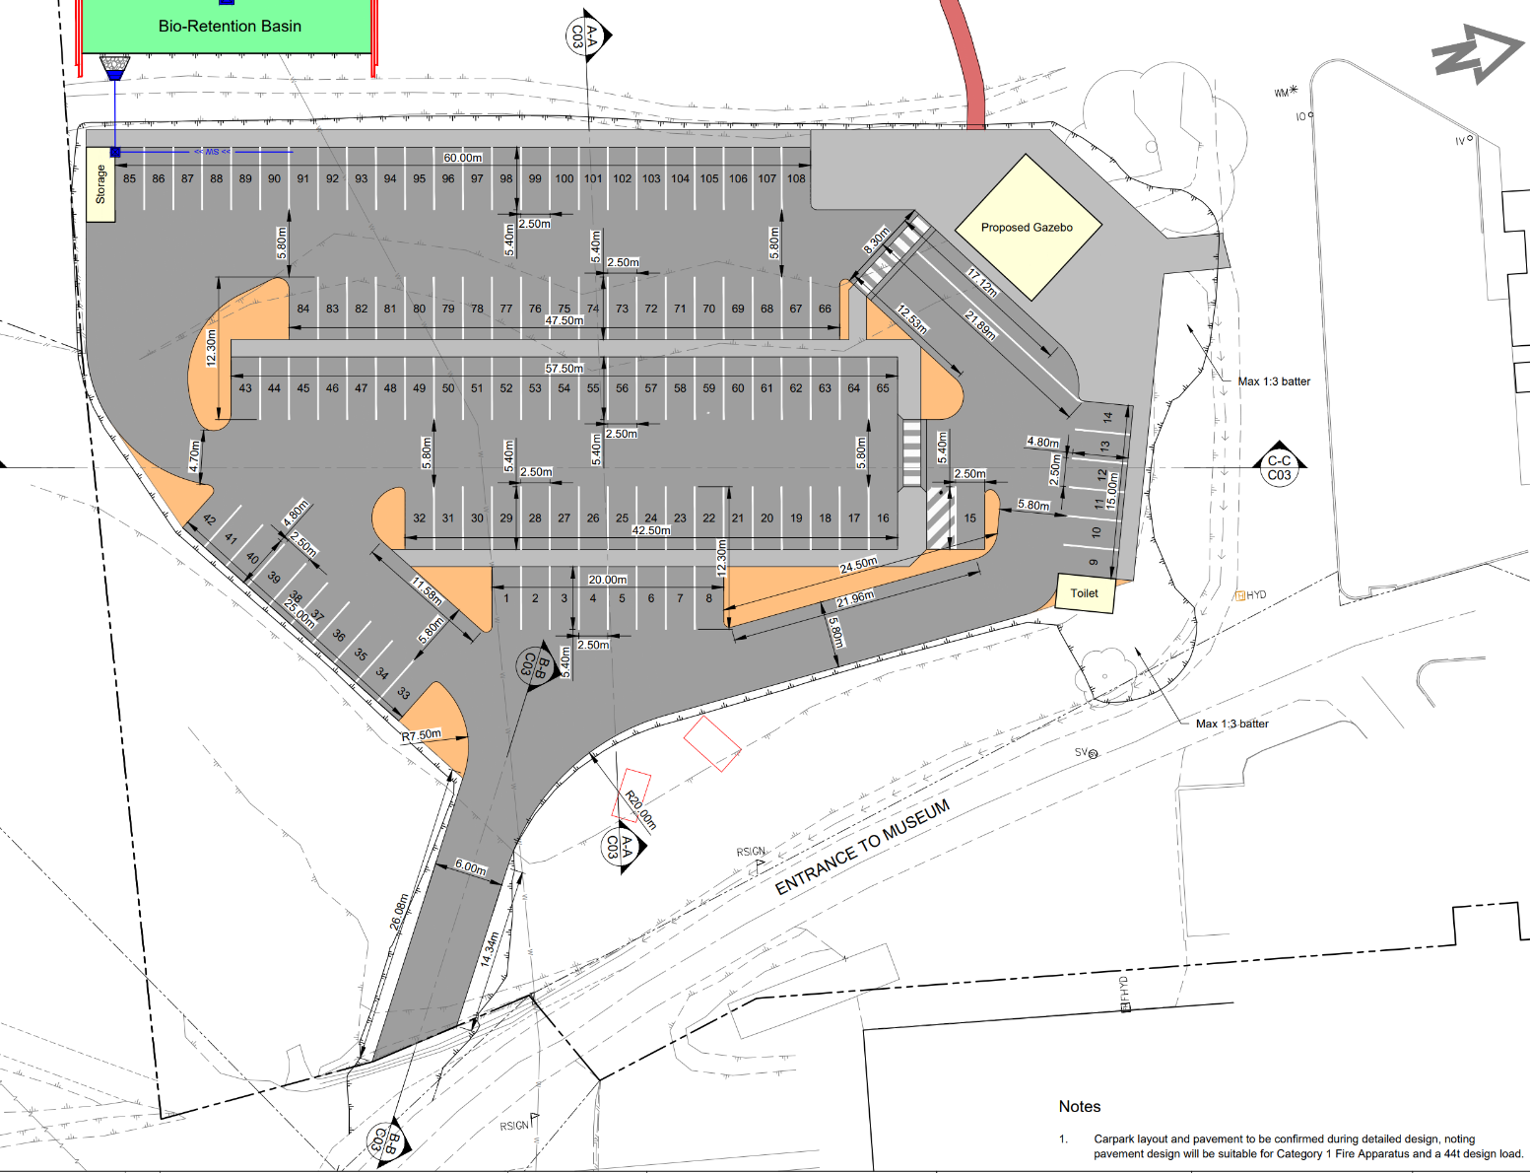
Plan 1: Car Park Layout Plan, Mining Museum, 22 August 2025

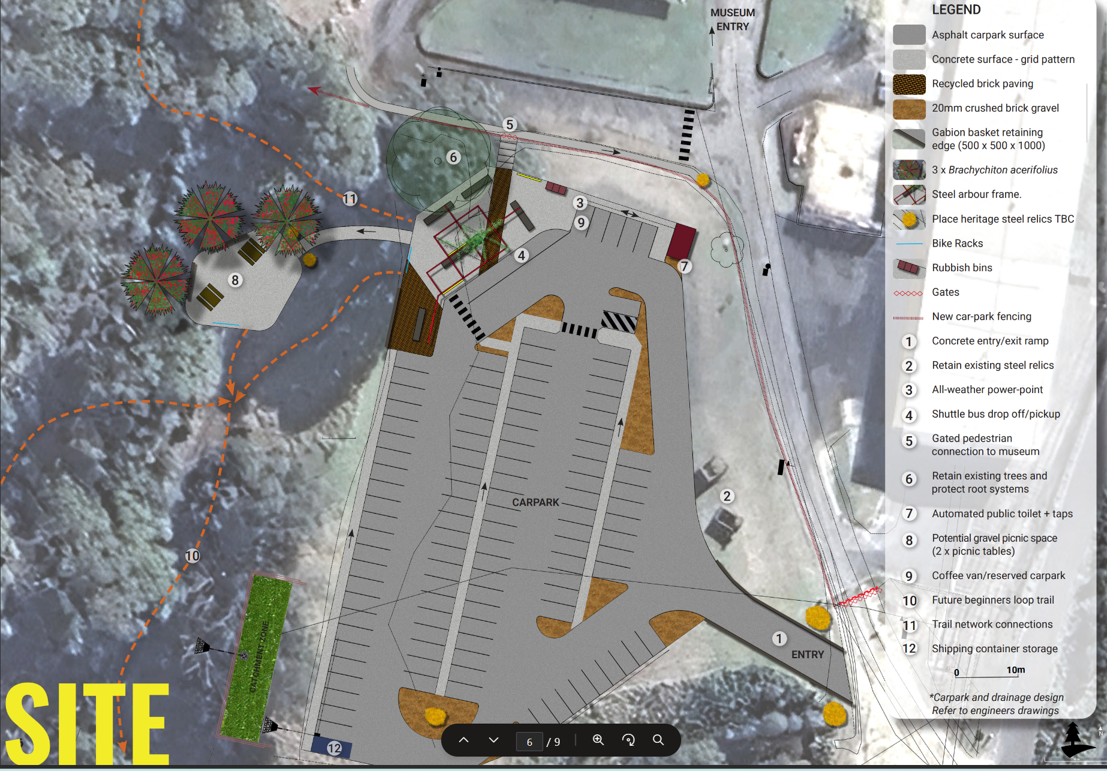
Plan 2: Carpark and Trailhead Concept Plan/Landscape Plan, Mining Museum, August 2025

  - Background

The development application was lodged on 25 October 2025. A chronology of the development application since lodgement is outlined below including the Panel’s involvement (briefings, deferrals etc) with the application:
Table 1: Chronology of the DA
Date | Event
25 October 2025 | DA lodged
5 November 2025 | Exhibition of the application to surrounding properties and to External Government Authorities
18 December 2025 | An RFI was issued to the applicant requesting additional information relating to:  - Biodiversity,  - Department of Climate Change, Energy, the Environment and Water-Water Group requirements and  - Community Concerns.
29 January 2026 | The NSW Police Force requested that a Crime Prevention Through Environmental Design (CPTED) be addressed.
18 February 2026 | An onsite meeting was undertaken with the Planning Panel and Council staff.
18 February 2026 | CPTED was received from the applicant and assigned to NSW Police Force via the planning portal.
9 March 2026 | The applicant submitted additional information relating to water course crossings for the Department of Climate Change, Energy, the Environment and Water-Water Group.
24 March 2026 | The applicant submitted additional information relating to biodiversity, crime prevention and community concerns.

  - Site History

The site is located across part of the former Lithgow State Mine, which was an underground coal mine that commenced construction in 1916, mined its first coal from its underground workings in 1921 and then continued as an underground coal mine until operations ceased in 1951.

The headworks of the mine primarily operated from a number of mine shafts located on the current State Mine Heritage Park area at the base of the State Mine Gully.

The mine headworks comprised a large power house that consisted of eight boilers to burn coal to power the mine workings. A railway line extended into the gully from the Lithgow Railway Yard, with coal export from the mine used for coal fired rail locomotives. A number of magazine huts were also located in the western part of the mine site to store explosives for usein the mining operations.

This power station, located to the east of the mine site and on the eastern side of State Mine Gully Road, operated between 1928 and 1969 and was originally built to supply power to the mine and to various factories within Lithgow, however, over time it was increased in size and provided power to the local area as well as to the Blue Mountains.

The decommissioning of the power station and demolition works were completed in 1976.

The former Lithgow State Mine operated to extract coal from the lower units of the Lithgow Coal Seam with the main shafts extended to more then 80 metres below ground surface and mined coal from a seam that ranged between 1 to 3 m in thickness. The coal produced from this coal seam was a high energy thermal coal, yielding medium ash with a low to moderate sulphur and phosphorus content.

Since the closure of the mine, the site has become a local tourist attraction showcasing the historical mining elements within the museum and around the site.

- STATUTORY CONSIDERATIONS

When determining a development application, the consent authority must take into consideration the matters outlined in Section 4.15(1) of the EP&A Act. These matters as are of relevance to the development application include the following:

- the provisions of any environmental planning instrument, proposed instrument, development control plan, planning agreement and the regulations
(i) any environmental planning instrument, and
(ii) any proposed instrument that is or has been the subject of public consultation under this Act and that has been notified to the consent authority (unless the Planning Secretary has notified the consent authority that the making of the proposed instrument has been deferred indefinitely or has not been approved), and
(iii) any development control plan, and
(iiia) any planning agreement that has been entered into under section 7.4, or any draft planning agreement that a developer has offered to enter into under section 7.4, and
(iv) the regulations (to the extent that they prescribe matters for the purposes of this paragraph),
that apply to the land to which the development application relates,
- the significant likely impacts of that development, including environmental impacts on both the natural and built environments, and social and economic impacts in the locality,
- the suitability of the site for the development,
- any submissions made in accordance with this Act or the regulations,
- the public interest.

These matters are further considered below.

It is noted that the proposal is considered to be:

- Integrated Development (Section 4.46 of the EP&A Act)
- Requiring concurrence/referral (Section 4.13 of the EP&A Act)

  - Environmental Planning Instruments, proposed instrument, development control plan, planning agreement and the regulations

The relevant environmental planning instruments, proposed instruments, development control plans, planning agreements and the matters for consideration under the Regulation are considered below.

- Section 4.15(1)(a)(i) - Provisions of Environmental Planning Instruments

The following Environmental Planning Instruments are relevant to this application:

- Conveyancing Act 1919,
- Environmental Planning and Assessment Regulation 2021,
- State Environmental Planning Policy (Biodiversity & Conservation) 2021,
- State Environmental Planning Policy (Planning Systems) 2021,
- State Environmental Planning Policy (Resilience & Hazards) 2021,
- State Environmental Planning Policy (Transport and Infrastructure) 2021,
- Lithgow Local Environmental Plan 2014 (LLEP2014) and
- The Lithgow Development Control Plan 2021.

A summary of the key matters for consideration arising from these State Environmental Planning Policies are outlined in Table 2 and considered in more detail below.

Table 2: Summary of Applicable Environmental Planning Instruments

EPI | Matters for Consideration | Comply (Y/N)
Conveyancing Act 1919 | Part 6 Covenants and Powers  Division 4 Easements and Restrictive and Positive Covenants  The Deposited Plan (DP 1240259) shows an existing right of carriageway that burdens Lot 10 and benefits Lot 11.  The terms of the right of carriageway does not place any restrictions of the use of the right of carriageway other than that it cannot be for residential purposes.  No works are proposed to be undertaken on Lot 10. | Yes
Environmental Planning and Assessment Regulation 2021 | 66A Council-related development applications—the Act, s 4.16(11)  (1) A council-related development application must not be determined by the consent authority unless—  (a) the council has adopted a conflict of interest policy, and  (b) the council considers the policy in determining the application.  Council’s 7.6 Policy Development Applications by Councillors And Staff (including immediate relatives), Or On Council Owned Land & Conflicts of Interest has been considered as part of the application process due to part of the development being undertaken on Council owned land.  The application will therefore be determined by the Regional Planning Panel for consideration. | Yes
State Environmental Planning Policy (Biodiversity & Conservation) 2021 | Chapter 3: Koala Habitat Protection 2020  This policy aims to encourage the conservation and management of areas of natural vegetation that provide habitat for koalas to support a permanent free-living population over their present range and reverse the current trend of koala population decline. The SEPP replaces the previous State Environmental Planning Policy No 44 - Koala Habitat Protection.  Chapter 3 applies to land of more than 1 hectare in area.  Chapter 4: Koala Habitat Protection 2021  Section 4.8 requires that the application must be consistent with the approved koala plan of management that applies to the site.  The site is within the Central and Southern Tablelands Koala Management Area. At this stage Lithgow has no Koala Management Plan endorsed.  The application undertook a Biodiversity assessment that identified targeted surveys for the Koala did not detect the species within the site. No prior records of the Koala are also known within the C3 area, with one historical record, from 1985, occurred within 120m of the site. The closest record within the last 18 years is located c. 1.8 km from the site. On this basis, the site does not constitute core Koala habitat.  As the proposal does not involve the removal of mature trees, the potential for adverse impacts on koala habitat is considered minimal.  Chapter 6: Water Catchments  The development site is located within the Sydney Drinking Water Catchment.  The development was referred to the Water NSW with a satisfactory response received. | Yes
State Environmental Planning Policy (Planning Systems) 2021 | Chapter 2: State and Regional Development  Section 2.19(1) declares the proposal to be regionally significant development under Clause 3(b) of Schedule 6 as the estimated development cost exceeds $5m and includes council owned land.  The Western Regional Planning Panel is the consent authority by virtue of section 4.5(b) of EP&A Act. | Yes
SEPP (Resilience & Hazards) | Chapter 4: Remediation of land  Contamination and remediation has been considered in the Contamination Report and the proposal is satisfactory subject to conditions. | Yes
State Environmental Planning Policy (Transport and Infrastructure) 2021 | Chapter 2: Infrastructure  Subdivision 2 Development likely to affect an electricity transmission or distribution network  Section 2.48(2) (Determination of development applications—other development) – electricity transmission - the proposal satisfies this section, subject to recommended conditions.  Section 2.99 Excavation in, above, below or adjacent to rail corridors – the proposal satisfies the SEPP and no referral to the Rail Authority is required. | Yes
Lithgow Local Environment Plan 2014 (LLEP2014) | Clause 2.3 – Zone Objectives and Land Use Table  Clause 5.10 - Heritage Conservation  Clause 5.21 - Flood Planning  Clause 7.1 – Consideration of earthworks  Clause 7.3 – Stormwater management  Clause 7.4 - Terrestrial Biodiversity  Clause 7.5 - Groundwater Vulnerability  Clause 7.7 - Sensitive Lands  Clause 7.10 Essential services | Yes
Lithgow Development Control Plan 2021 (LDCP2021) | Chapter 2 – Site Requirements  Chapter 3 – Environment and Hazards  Chapter 4 – Heritage and Cultural Conservation  Chapter 8 – Rural & Other Land Uses | Yes.

Further consideration of the relevant SEPPs are outlined in more detail below:

State Environmental Planning Policy (Biodiversity and Conservation) 2021 (B&C SEPP)

Chapter 6: Water Catchments

The B&C SEPP applies to the development pursuant to clause 6.1, as the development is located within the Sydney Drinking Water Catchment.

Part 6.5 of Chapter 6 lists several controls that development within a regulated catchment must consider when determining to grant consent. As such, the development was referred to Water NSW.

Water NSW has provided the following comments:
The subject property, which has been inspected by Water NSW, is located within the Warragamba catchment which forms part of Sydney's water supply.

Water NSW notes the following from its assessment of the application:
- Little information has been provided regarding how wastewater generated in the public toilet/amenities will be managed. It is noted the Operational Plan of Management suggests that the preliminary civil design has taken into account the location of the existing water, sewer and electrical supply to the museum on the site, should they be required after detailed design. Water NSW has undertaken its assessment on the basis of the site being connected to Councils sewerage system.
- The site predominantly comprises steep gully slopes that converge on State Mine Gully and State Mine Creek – which is the only named waterway within the site. The Geotech Assessment identifies the site soils are potentially susceptible to erosion, and soil disturbance should be minimised and soils protected. The proposed design seeks to minimise soil disturbance through reduced trail widths, rock platforms and use of existing trails, where present. Adequate drainage will be installed across the trails to manage water flow along or across them and trail alignment and construction techniques will ensure the retention of all established trees. Adjustable rock matting and rock armouring are also proposed for sections that frequently remain wet to minimise erosion and improve traction on steeper slopes. Water NSW notes that appropriate maintenance and management of the trails and associated drainage, stabilisation methods and discharge points is essential to ensure the site does not present a significant sediment and erosion hazard. Restrictions regarding site use during adverse weather conditions (particularly heavy and/or sustained rainfall) should also be considered, and associated discharge points should be appropriately stabilised such that discharge does not cause erosion.
- The stormwater impact assessment and associated MUSIC stormwater quality modelling have focused on works associated only with the development of the trail head facilities and carpark. In
- this case, Water NSW considers that the appropriate design, maintenance and management of the trails and associated sediment and erosion controls, as outlined above, will have benefits for stormwater quality and management.
- A proposed, separate 35km new trail network spanning across the Gardens of Stone State Conservation Area and the State Mine Gully precinct complementing the proposed trail network does not form part of this application.
- The proposed bike trails intersect existing drainage lines and watercourses at several points across the site with rock armouring proposed for these crossings. The trail head facilities, including the proposed carpark, are also located within 40m of an unnamed tributary of State Mine Creek. Water NSW considers that the development must be consistent with the requirements of any Controlled Activity Approval under the Water Management Act 2000 from the Department of Climate Change, Energy, the Environment and Water (DCCEEW), where applicable.

The above matters are addressed in draft conditions of consent.
Based on the site inspection and the information provided, Water NSW considers that the proposed development can achieve a neutral or beneficial effect (NorBE) on water quality provided appropriate conditions are included in any development consent and are subsequently implemented.
Water NSW concurs with Council granting consent to the application subject to conditions.

State Environmental Planning Policy (Planning Systems) 2021 (Planning Systems SEPP)

Chapter 2: State and Regional Development

The proposed development has an estimated development cost of more than $5 million and the development involves Council owned land. Therefore, the proposal is ‘regionally significant development’ pursuant to clause 2.19(1) and clause 3(b) of Schedule 6 of the Planning Systems SEPP.

The Western Regional Planning Panel is the consent authority by virtue of section 4.5(b) of the EP&A Act.

State Environmental Planning Policy (Resilience and Hazards) 2021 (R&H SEPP)

Chapter 4: Remediation of Land

The southern area of the site has historically been used for coal mining purposes and was subsequently converted to the State Mine Heritage Park and Museum which is accessible to the public.

The proposal seeks approval for the construction of mountain biking trails through the bushland surrounding the site as a mountain bike park and the construction of a car park and ancillary supporting infrastructure within the State Mine Heritage Park part of the site.

Records show that the section utilised by the former coal mine operations does not appear to have been occupied by any mine shafts, railway operations, powerhouses or other mine structures. Since the closure of the mine in the early 1950s the former mine site has remained relatively unchanged, with no significant developments apart from the demolition of some structures and construction of a new shed.

Stockpiles of discarded coal chitter were placed around the southern area of the site to form the current elevated mound.

The contamination report submitted with the application concluded the following:

Whilst a source of potential contamination to the surface and sub-surface of the southern area of the Site could be from the underlying coal chitter, raw coal or any associated coal ash, given that the mounded area has been present for many decades and is covered by grasses and potentially a layer of soils, the risk of a contamination being present at the surface or near surface that would present a risk of harm to human health is considered to be low to negligible.

Whilst abandoned coal mine workings can present at risk of producing methane, the depth and extensive nature of the underground coal mine workings beneath areas of the Site are known to be flooded, in which the risk of such gas being generated and migrating to the surface such that it could create a risk of harm to users of the Site is considered to be unlikely. Similarly, coal chitter present in stockpiled or placed areas can have a risk of combusting, which could pose a risk to the safety of users of this area of the Site, however, it is considered that such a risk under usual conditions would be unlikely.

The results have not identified conditions or potential conditions that are considered to affect the suitability of the Site for the open space and recreational uses proposed by the mountain bike park. Overall, it is considered that the Site is suitable for open space and recreational land use.

Having regard to above, it is considered that the site is consistent with the requirements of Resilience and
Hazards SEPP and is suitable for the proposed land use.

State Environmental Planning Policy (Transport and Infrastructure) 2021 (T&I SEPP)

Chapter 2: Infrastructure

Section 2.48(2) (Determination of development applications—other development) – electricity transmission - the proposal satisfies this section, subject to recommended conditions.

The development was referred to Endeavour Energy who has no objection to the application subject to recommended conditions being placed on the consent.

Section 2.99 Excavation in, above, below or adjacent to rai corridors
(1) This section applies to development (other than development to which section 2.101 applies) that involves the penetration of ground to a depth of at least 2m below ground level (existing) on land—
(a) within, below or above a rail corridor, or
(b) within 25m (measured horizontally) of a rail corridor, or
(c) within 25m (measured horizontally) of the ground directly below a rail corridor, or
(d) within 25m (measured horizontally) of the ground directly above an underground rail corridor.

The development is in proximity to a railway line with a corner of the proposed carpark area and access to be within 25m. The development however does not propose to excavate/penetrate the 2m below the ground level. The finished surface area is proposed to follow the existing surface area with minor fill to occur. This is shown in the plan below:

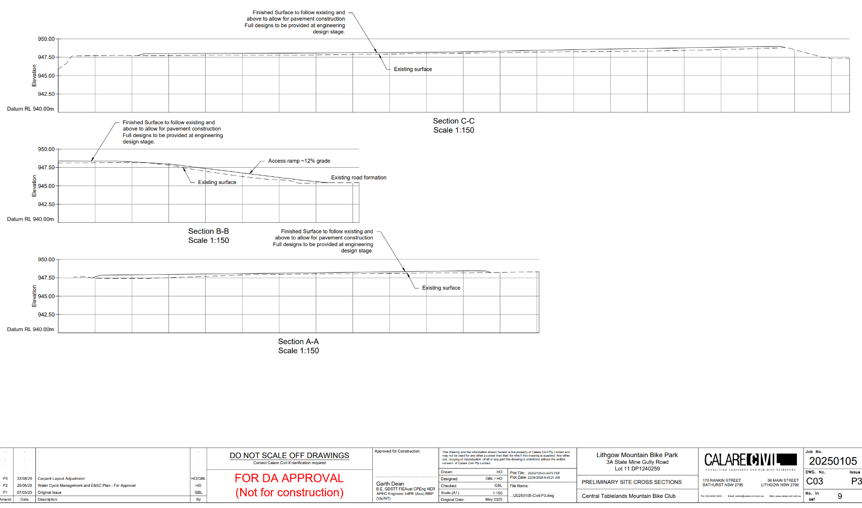
Plan 3: Site Cross Section for the access carpark area

Lithgow Local Environmental Plan 2014

The relevant local environmental plan applying to the site is the Lithgow LEP. The aims of the LEP include:

(aa) to protect and promote the use and development of land for arts and cultural activity, including music and other performance arts,

(a) to encourage sustainable and planned development that complements the unique character and amenity of Lithgow and enhances its towns, villages and rural areas,

(b) to provide for a range of development opportunities that contribute to the social, economic and environmental resources of Lithgow in a way that allows the needs of present and future generations to be met by implementing the principles of ecologically sustainable development,

(c) to manage, facilitate and encourage sustainable growth and development that—

(i) promotes the efficient and effective delivery of utilities, infrastructure and service and minimises long-term costs to government, authorities and the community, and

(ii) protects, enhances and conserves mineral and extractive resources lands, forests and agricultural lands and the contributions they make to the local, regional and State economy, and

(iii) allows for the orderly growth of land uses while minimising conflict between land uses in a zone and land uses in adjoining zones, and

(iv) encourages a range of housing choices in planned urban and rural locations to meet population growth and the diverse needs of the community, and

(v) preserves and protects land that has been identified for future long-term urban development from inappropriate fragmentation and development, and

(vi) protects and enhances environmentally sensitive areas, ecological systems, areas of high scenic, recreational, landscape or conservation value and areas that have the potential to contribute to improved environmental outcomes, and

(vii) protects and enhances places and items of environmental, archaeological, cultural or heritage significance, including Aboriginal relics and places, and

(viii) avoids or minimises the impact of development on drinking and environmental water catchments to protect and enhance water availability and safety for human consumption and the maintenance of environmental and recreational values, and

(ix) strengthens and promotes employment land opportunities and appropriate tourism development and growth, and

(x) creates resilience to natural hazards through local land use planning.

The proposal is consistent with these aims as the proposal will contribute to the economic well-being of the community, in a socially and environmentally responsible manner and strengthen the position of Lithgow by encouraging employment and economic growth.

Zoning and Permissibility

The proposed development is located within the C3 Environmental Management land use zone under Clause 2.3 of the Lithgow LEP.

The land use is defined as being an “recreation area” under the Lithgow LEP.

Definition

recreation area means a place used for outdoor recreation that is normally open to the public, and includes—
(a) a children’s playground, or
(b) an area used for community sporting activities, or
(c) a public park, reserve or garden or the like,
and any ancillary buildings, but does not include a recreation facility (indoor), recreation facility (major) or recreation facility (outdoor).

Figure 5 below shows the Lithgow LEP zoning map of the property:
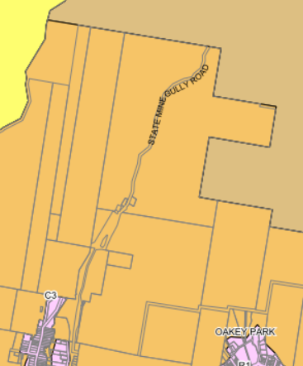
Figure 5: Zoning map (LLEP2014)

The zone objectives include the following (pursuant to the Land Use Table in Clause 2.3):

Zone | Objectives of zone
C3 Environmental Management | • To protect, manage and restore areas with special ecological, scientific, cultural or aesthetic values.  • To provide for a limited range of development that does not have an adverse effect on those values.  • To facilitate the management of environmentally sensitive lands and riparian areas.  • To protect and conserve the vegetation and escarpment landscape surrounding Lithgow.  • To maintain or improve the water quality of receiving water catchments.

The development is considered to be consistent with the zone objectives as:

- The proposed development will facilitate the use of the site for outdoor recreation, being for mountain bike riding and bush walking, for members of the public.
- The ecological, scientific, cultural or aesthetic values of the area will be protected and managed where possible with the design of the track to utilise existing tracks and cleared areas where possible and minimize the removal of vegetation as much as possible. A biodiversity assessment was undertaken for the development that provided management and mitigation procedures for the development.
- The development has been adequately designed with stormwater models and infrastructure. This has been assessed by WaterNSW and is found to be satisfactory.

General Controls and Development Standards (Part 7)

The Lithgow LEP contains controls relating to development standards, miscellaneous provisions and additional local provisions. The controls relevant to the proposal are considered below.

Control | Requirement | Proposal | Comply
Heritage Conservation (Cl 5.10) | Heritage assessment: The consent authority may, before granting consent to any development—  (a) on land on which a heritage item is located, or  (b) on land that is within a heritage conservation area, or  (c) on land that is within the vicinity of land referred to in paragraph (a) or (b),  require a heritage management document to be prepared that assesses the extent to which the carrying out of the proposed development would affect the heritage significance of the heritage item or heritage conservation area concerned.  (7) Archaeological sites: The consent authority must, before granting consent under this clause to the carrying out of development on an archaeological site (other than land listed on the State Heritage Register or to which an interim heritage order under the Heritage Act 1977 applies)—  (a) notify the Heritage Council of its intention to grant consent, and  (b) take into consideration any response received from the Heritage Council within 28 days after the notice is sent. | Lots 10 and 11 DP 1240259 (formerly 1/242977), being the State Mine Heritage Park, are identified as Archaeological heritage.  The State Mine Heritage Park is currently used for tourism and education purposes. It is expected that the development will complement the existing use of the site by providing recreation and tourism activities.  The State Heritage Park is located at the entrance to the development. A carpark and amenities building will be constructed in this location some distance from the heritage building. The development will not affect the existing buildings and heritage items on the site.  An Aboriginal Cultural Heritage Due Diligence Assessment was prepared and submitted with the application.  One recorded heritage site under Aboriginal Heritage Information Management System (AHIMS) was identified within the development locality.  Visual inspections of the site identified five areas of archaeological sensitivity; State Mine Heritage Park and State Mine Heritage Park Shelters with Artefacts.  Trails have been designed and located to avoid any known aboriginal heritage relics or sites of significance.  Therefore, it is concluded that the proposed works will have no impact to Aboriginal objects or archaeological deposits given that the proposed works are limited to ground surface only.  The assessment includes recommendations and management measures to protect Aboriginal cultural values. The Aboriginal Due Diligence Assessment Report (including the recommendations in the report) would be conditioned on the consent as a supporting documentation to the DA should the application be approved.  The application was further referred to the Heritage Council (Heritage NSW) as per the LEP 2014. Heritage NSW is satisfied that the development would have minimal impact to archaeological sites in the area. | Yes
Flood Planning  (Cl 5.21) | In deciding whether to grant development consent on land to which this clause applies, the consent authority must consider the following matters—  (a) the impact of the development on projected changes to flood behaviour as a result of climate change,  (b) the intended design and scale of buildings resulting from the development,  (c) whether the development incorporates measures to minimise the risk to life and ensure the safe evacuation of people in the event of a flood,  (d) the potential to modify, relocate or remove buildings resulting from development if the surrounding area is impacted by flooding or coastal erosion. | A Stormwater Management Plan was submitted with the application as the proposed car park is located within the floodplain of State Mine Creek.  The Report identifies that although within the floodplain, due to being situated on top of a chitter heap the site is immune from flood impacts in all events up to and include 0.2% AEP Event (500 yr ARI).  The Report further states that Council’s State Mine Gully Road is compromised in much more frequent events as the road becomes inundated, 200m downstream of the site, during events greater than and including the 10% AEP Event (10yr ARI).  The picnic area is located within the flood planning area, but would not adversely affect flood behaviour given the nature of the facilities.  The mountain bike trails are predominantly outside of the flood planning area and will be unaffected by flood and will not impact flood behaviour.  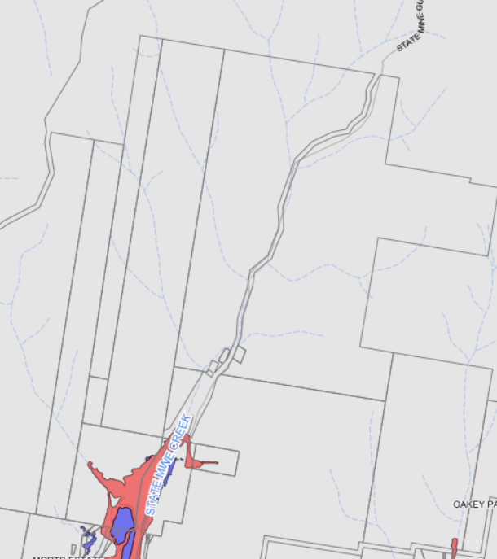  State Mine Heritage Park and Flood prone mapping under the Lithgow LEP 2014 | Yes
Earthworks (Cl 7.1) | In deciding whether to grant development consent for earthworks (or for development involving ancillary earthworks), the consent authority must consider the following matters—  - the likely disruption of, or any detrimental effect on, drainage patterns and soil stability in the locality of the development,  - the effect of the development on the likely future use or redevelopment of the land,  - the quality of the fill or the soil to be excavated, or both,  - the effect of the development on the existing and likely amenity of adjoining properties,  - the source of any fill material and the destination of any excavated material,  - the likelihood of disturbing relics,  - the proximity to, and potential for adverse impacts on, any waterway, drinking water catchment or environmentally sensitive area,  - any appropriate measures proposed to avoid, minimise or mitigate the impacts of the development,  - the proximity to, and potential for adverse impacts on, any heritage item, archaeological site or heritage conservation area. | The development includes earthworks for the construction of the carpark and construction of the mountain bike trails.  A Geotechnical Report was submitted with the application.  The location for the proposed car park and amenities is relatively level with the topography over the remainder of the trail site comprising steep cliffs and slopes with the trails rising up and along the gullies and ridges. The trails will utilise existing tracks to limit vegetation removal and to ensure stabilisation of the soil is maintained.  elevations range from 950m AHD at the trailhead to approximately 1150 AHD in the north and 1050 along the western boundary.  A maximum 1:3 batter slope is proposed around the car park site.  The development is located within the Subsidence district area. The report identified that the likelihood of mine subsidence events occurring across the site is low as mine workings are in excess of 80m depth, with all shafts being remote from trail infrastructure.  The development was referred to Subsidence Advisory for comment who provided general terms of approval with conditions of consent.  The proposed development will have minimal impacts on drainage patterns and soil stability in the locality through construction in accordance with the stormwater management plan.  Conditions of consent will be imposed to ensure dust, noise and erosion impacts are minimised during works and in perpetuity as a result of the earthworks.  Conditions of consent will also be imposed to control erosion and sedimentation impacts on the site. | Yes
Stormwater Management (Cl 7.3) | In deciding whether to grant development consent for stormwater management, the consent authority must consider the following matters—  - is designed to maximise the use of water permeable surfaces on the land having regard to the soil characteristics affecting on-site infiltration of water, and  - includes, if practicable, on-site stormwater retention for use as an alternative supply to mains water, groundwater or river water, and  - avoids any significant adverse impacts of stormwater runoff on adjoining properties, native bushland and receiving waters, or if that impact cannot be reasonably avoided, minimises and mitigates the impact. | A stormwater management plan and water quality assessment has been undertaken for the carpark area. The trails do not require stormwater assessment given that minimal vegetation will be removed.  All runoff from the proposed car park area is proposed to be directed to a bio-retention basin in the southwest corner, which forms part of the development.  The stormwater management has been assessed against the WaterNSW water quality guidelines and Norbe Assessment.  The development was referred to WaterNSW who has given concurrence subject to conditions on the consent.  The development was also assessed by Council’s Engineers who considers the development to have adequate drainage. | Yes
Terrestrial Biodiversity  (Cl 7.4) | (3) In deciding whether to grant development consent for development on land to which this clause applies, the consent authority must consider—  a) whether the development is likely to have—  (i) any adverse impact on the condition, ecological value and significance of the fauna and flora on the land, and  (ii) any adverse impact on the importance of the vegetation on the land to the habitat and survival of native fauna, and  (iii) any potential to fragment, disturb or diminish the biodiversity structure, function and composition of the land, and  (iv) any adverse impact on the habitat elements providing connectivity on the land, and  b) any appropriate measures proposed to avoid, minimise or mitigate the impacts of the development. | The site is located within an environmentally sensitive area that contains ‘terrestrial biodiversity’.  A Biodiversity Development Assessment Report was submitted with the development application. The report identifies the proposal would occupy an area of 2.92ha of which 2.36ha possesses remnant native vegetation.  The native vegetation present in the disturbance footprint consists of four Plant Community Types  (PCTs):  - 3687 – Newnes Plateau Peppermint-Ash Tall Forest.  - 3688 – Newnes Plateau Silvertop Ash Woodland.  - 3696 – Western Blue Mountains Rocky Scribbly Gum Woodland.  - 3862 – Newnes Plateau Rockplate Heath.  Twenty two (22) Species were assumed present as ecosystem credit species, generating a total of 35 ecosystem credits. Five species credit species considered to be at risk of a Serious and Irreversible Impact. One species – the Swift Parrot could be excluded from consideration as the site does not fall within the area mapped as important habitat for the species. Three further species were eliminated by targeted surveys. The Large-eared Pied Bat was detected during targeted surveys and is considered present for the purposes of determining offsets. One additional non-SAII species – the Southern Greater Glider – was detected during surveys and was added to the offset calculations for the proposal. These two species would generate a total of 115 species credits, comprising 69 credits for the Large-eared Pied Bat and 46 credits for the Southern Greater Glider.  The proponent intends to purchase and retire the necessary number of credits on the open market or, if not available, offset credits through a direct payment into the Biodiversity Conservation Fund.  This would be conditioned on the consent should the application be recommended for approval. | Yes
Sensitive Lands  (Cl 7.7) | Development consent must not be granted to development on land to which this clause applies unless the consent authority is satisfied that—  (a) the development is designed, sited and will be managed to avoid significant adverse environmental impact, or  (b) if that impact cannot be avoided—the development is designed, sited and will be managed to minimise that impact, or  (c) if that impact cannot be minimised—the development will be managed to mitigate that impact. | The site of the proposed development is situated on and around a steep escarpment and traverses tall sandstone cliffs containing caves, crevices, overhangs and similar formations.  Exposed areas of the plateau support rocky heath communities, containing both large, embedded boulders and loose surface rock, as  well as eroded sandstone pagodas.  Accumulated rocky debris occurs around the base of some cliffs, and within drainage lines and creeks.  Large areas of the site exceed a 25% gradient: specially for the trails. The trails are therefore proposed to be designed and constructed in a manner to sensitively navigate the gradients and retain all established trees where possible to minimise site disturbance.  The car park and trail heads are located within the flat areas of the site, avoiding the need for any significant excavation and are sited so as not to impede drainage, avoid permanent inundation and to avoid any impact on flood behaviour.  The soil landscapes across the site are not listed as having a significant salinity risk.  The Geotech Assessment identifies that the soils encountered on the site are potentially susceptible to erosion, and soil disturbance should be minimised and protected by vegetation where exposed.  The design of the proposed development has sought to minimise soil disturbance through reduced trail widths, rock platforms and existing trails where present to minimise ground disturbance. Trail alignments and construction techniques will also be selected to ensure the retention of all established trees.  Although, the site is mapped as Environmentally Sensitive Land and contains steep topography, the site does not contain geology consistent with karst presence, does not present risk of soil salinity, impeded drainage or permanent inundation. There is the potential for erosion and through appropriate trail design and vegetation retention, soil disturbance can be minimised.  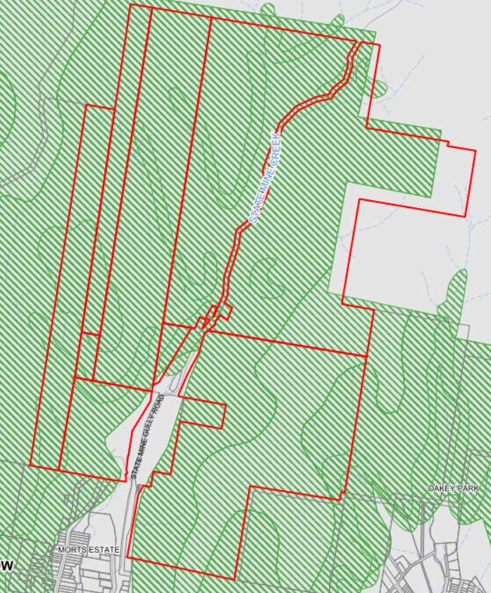 | Yes
Essential Services  (Cl 7.10) | Development consent must not be granted to development unless the consent authority is satisfied that any of the following services that are essential for the development are available or that adequate arrangements have been made to make them available when required—  the supply of water,  the supply of electricity,  the disposal and management of sewage,  stormwater drainage or on-site conservation,  suitable vehicular access. | Vehicular access to the site will be provided via State Mine Gully Road Road, upgraded in accordance with Council’s Engineering requirements.  The development will be connected to water, electricity and sewer. Stormwater will discharged to a bioretention basin on-site.  As such, the development will have all essential services required to comply with clause 7.10. | Yes

The proposal is considered to be generally consistent with the LEP.

- Section 4.15 (1)(a)(ii) - Provisions of any Proposed Instruments

There are currently no proposed instruments relevant to the development.

- Section 4.15(1)(a)(iii) - Provisions of any Development Control Plan

Section 4.15(1)(a)(iii) of the EP&A Act requires Council to consider the provisions of any development control plans.

The development has been assessed having regard to the relevant desired outcomes and prescriptive requirements within the Lithgow Development Control Plan 2021 (LDCP2021).

Lithgow Development Control Plan 2021

LDCP2021  Clause | Requirement | Assessment Comments | Compliance
Chapter 2 – Site Requirements | Site Analysis demonstrates that the design of the proposed development has responded to an analysis of the site and its relevant context. | The development complies with the land use zone and its objectives.  The development has been designed to minimise potential impacts to surrounding land uses where possible, specifically in relation to heritage conservation, setbacks, visual, traffic, noise and to minimise potential earthworks.  The surrounding developments consist of the Gardens of Stone State Conservation Area to the north and east of the site. Morts Estate being an urban area is located to the south, and Cobar Park being a densely vegetated area is to the west.  As such the development has been designed (in terms of setbacks and scale) to be consistent with the surrounding context.  The size of the development is considered to be suitable for the land.  The development will support safe access to and from the site via State Mine Gully Road, subject to minor upgrade works such as line marking and directional signs.  The development has also been assessed in accordance with bushfire, water and subsidence requirements. | Yes
2.2 Site Analysis, Local Character and Context |  |  | Yes
2.2.2 Site Analysis & Development Response |  |  | Yes
2.2.3 Local Character & Context | Character: All applications demonstrate that the proposed development has considered the local existing and desired future character of the area and that the proposed development is consistent with and/or integrates with this character. | The property currently retains the Lithgow State Mine Gully Heritage Park. This consists of former heritage buildings and a new shed.  The surrounding developments consist of the Gardens of Stone State Conservation Area to the north and east of the site. Morts Estate being an urban area is located to the south, and Cobar Park being a densely vegetated area is to the west.  The carpark and amenities are proposed to be located within the boundaries of the State Mine Gully Heritage Park and will contain adequate setbacks. There will be no impact in terms of overshadowing or privacy to the adjoining properties.  Landscaping has been integrated into the design of the development with different types of species proposed to be planted throughout the carparking area.  The development has been designed to suit and integrate with the existing and future character of the area. | Yes
2.2.4 Visually Prominent Sites | Development on a visually prominent site, particularly in rural and/or environmental zones or in heritage conservation areas, is sited and designed to minimise visual and environmental impact. | The development site is not a visually prominent site. The development is to be located on the outskirts of the Lithgow township utilising an existing built site and existing tracks, thereby minimising visual and environmental impact.  The development therefore complies with clause 2.2.4 of the Lithgow DCP. | Yes
2.3 Slope Response, Earthworks & Retaining Walls | - Description: All development that involves any significant earthworks provides a plan and/or description of the location, extent and depth of earthworks that forms part of the application.  - LLEP2014: All development that involves any significant earthworks addresses Clause 7.1 - Earthworks of LLEP2014.  - Design: Developments on sloping sites are sited, designed and use construction techniques that respond to the topographical (slope) & hydrological (water) features of the site. Alternatives to slab on ground construction should be utilised where, due to gradient and characteristics of the site, such form of construction is inappropriate.  - Impact: Depending on the likelihood and significance of impact of any proposed earthworks on the matters raised in the objectives of this Section, Council may require justification for the need for those earthworks AND additional plans/reports/certification to demonstrate that the impacts can be avoided, mitigated or minimised (for examples, see table below).  - Drainage: Disturbance to natural drainage patterns is minimised and addresses Section 2.5 Stormwater Management of this DCP.  - Batters:  - Cut and fill batters do not exceed a slope of 1V:2H (vertical to horizontal) depending on soil classification or Council is satisfied of sufficient site stability by a Geo-technical and/or Structural Report; and  - All batters are to be provided with both short and long-term stabilisation to prevent soil erosion and do not extend onto public or adjoining land without permission. | The applicant has demonstrated through design plans, how the proposed development complies with the earthwork requirements including the need for batters.  The State Mine Heritage Park (for the proposed car park and amenities) is relatively level with the topography over the remainder of the trail site comprising steep cliffs and slopes with the trails rising up and along the gullies and ridges. These trails would be utilising existing tracks to limit vegetation removal and to ensure stabilisation of the soil is maintained.  The RL at the starting point area is about 950m AHD with the highest point towards the northern extent of the tails reaching 1150m AHD and along the western extent of the trails to about 1050m AHD.  A maximum 1:3 batter slope is proposed around the carparking site.  The development is located within the Subsidence district area. The report identified that the likelihood of mine subsidence events occurring across the site is low as workings are in excess of 80m depth, with all shafts being remote from trail infrastructure.  The development was therefore referred to Subsidence Advisory, who provided general terms of approval with conditions of consent.  The proposed development will have minimal impacts on drainage patterns and soil stability in the locality through construction in accordance with the stormwater management plan.  Conditions of consent will be imposed to ensure dust, noise and erosion impacts are minimised during works and in perpetuity as a result of the earthworks.  Conditions of consent will also be imposed to control erosion and sedimentation impacts on the site. | Yes
2.3.1 Earthworks  2.3.2 Retaining Walls |  |  | Yes
2.4 Stormwater Management | - Application: Development applications (in accordance with Council's DA Guide) may need to provide a Stormwater Drainage (Concept) Plan (SDCP) and/or Soil and Water Management Plan (SWMP) addressing stormwater management on the Site.  - Guidelines: All Stormwater drainage is designed to comply with Council's Engineering Guidelines – Section 3 – Stormwater Drainage.  - Drinking Catchment: Unless there is 'no identifiable potential impact', all development within the Sydney Drinking Water Catchment demonstrates a neutral or beneficial effect upon water quality in accordance with the requirements of SEPP (Sydney Water Drinking Catchment) 2011. | A stormwater management plan and water quality assessment has been undertaken for the carpark area. The trails do not require stormwater assessment given that minimal vegetation will be removed.  All runoff from the proposed car park area is proposed to be directed to a bio-retention basin in the southwest corner.  The stormwater management has been assessed against the WaterNSW water quality guidelines and Norbe Assessment.  The development was referred to WaterNSW who has given concurrence subject to conditions on the consent.  The development was also assessed by Council’s Engineers who considers the development to have adequate drainage. | Yes
2.5 Vehicle Access and Parking | All development is e.g., designed to be consistent with (as amended):  - Council’s Guidelines for Civil Engineering Design and Construction for Development (2012) ('Engineering Guidelines').  - RTA (now Transport for NSW) (2002) Guide to Traffic Generating Developments; and  - Relevant Australian Standards including but not limited to (as amended):  - AS2890 – Parking facilities including:  - AS2890.1 (2004) – Off-street car parking.  - AS2890.2 (2018) – Off-street commercial vehicle facilities.  iii. AS2890.3 (2015) – Bicycle parking facilities.  iv. AS2890.6 (2009) – Off-street parking for people with disabilities  - AS1428 – Design for Access and Mobility.  - Relevant Austroads Guidelines; and  - Relevant Council Policies. | Vehicle access to the carpark and trail head is proposed via the existing driveway entrance into the State Mine Gully Heritage Park and Museum. This access is considered to be satisfactory for the development in terms of site safety.  The slope of the driveway contains a maximum 5% grade. This is below the 25% grade as stated in the DCP.  The total width of the driveway is approximately 6.0m carriageway width with a 20m entrance/exit adjoining State Mine Gully Road. This complies with the minimum carriageway width.  A landscaping plan was submitted with the application and shows landscaping to be proposed around the carpark area.  The development was assessed by Council’s Engineer who considers the development to be adequate for the site and surrounding area subject to conditions being included on the consent. | Yes
2.5.4 Parking Location, Design & Circulation | 1) Parking Location,  2) Parking Design,  3) Accessible Parking,  4) Safety,  5) Sealed Vehicle Areas,  6) Stormwater,  7) Vehicle Sizes,  8) Operating Hours,  9) Basement Parking,  10) Stacked Parking,  11) Circulation,  12) Parking Navigation,  13) Lighting,  14) Visual Impact | Parking is proposed to be located towards the front section of the State Mine Gully Heritage Park, on a reasonably flat section, which is currently grassed and utilised as an informal carpark.  The proposal includes an allocated zone for the shuttle bus drop off/pickup.  Parking design therefore complies with Council’s Engineering Guidelines.  The carparking layout has been designed to minimise potential safety impacts around the site and enable adequate manoeuvring for all vehicles to leave the site in a forward direction.  Conditions would be applied to the consent to ensure the access to be sealed in accordance with Council’s Engineering Guidelines.  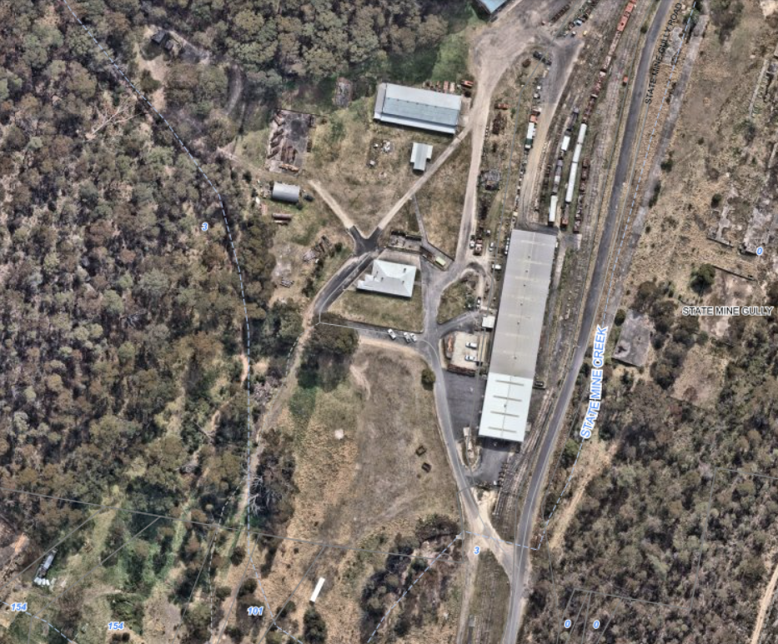  Proposed Car Park and Amenities  Entrance/Exit to the State Mine Gully Heritage Park | Yes
2.5.5 On-Site Parking Numbers | The DCP does not specify the number of parking spaces required for recreational activities. | The carparking area is proposed to consist of 111 spaces, (including an accessible space, staff parking, and minivan parking), including pedestrian walkways and landscaping.  As such, the number of car parking spaces to be provided for the development is considered satisfactory. | Yes
2.5.7 Bicycle Parking | The DCP does not specify the number of bicycle parking spaces required for recreational activities. | The development contains a number of bike racks within the vicinity of the carpark. | Yes
2.6 Pedestrian Access, Mobility & Safety | Accessibility  1) Access to Premises Standards,  2) National Construction Code,  3) Australian Standards.  Pedestrians  - Separation,  - Entrances,  - Mixed-Use Buildings,  - Access Ramps,  - Lighting. | The development was assessed by Council’s Building Officer and found to be satisfactory for the development subject to conditions on the consent.  Pedestrian access to the development is accessible via the carparking area. | Yes
2.7 Designing for Crime Prevention | Crime Risk Assessment  Objective 1  To ensure that new larger developments and subdivisions (see table below), and/or significant alterations and additions to existing larger developments (see table below) has:  - Considered how it may improve safety and reduce the facilitation of criminal activity.  - Demonstrated how the design has responded to the four (4) main principles of crime prevention including: territorial re-enforcement, surveillance, access control and space/activity management to create the perception or reality of reduced opportunity for crime or inappropriate behaviour.  - Provided appropriate lighting that enhances safety and security whilst minimising impacts from light-spill or inappropriate lighting on neighbouring properties. | Given the type of development being a carpark, crime prevention is not warranted. Fencing is existing around the State Mine Heritage Park with security cameras throughout the sheds and museum areas.  This is satisfactory for the development and complies with the DCP. | Yes
2.8 Utilities, Easements & Infrastructure | 2.8.1 – Connections Utilities  2.8.2 – Building Near Utilities/Easements/Drainage Lines  2.8.6 – Water Supply | The development is proposed to be connected to Council’s water and sewer services.  The application has been assessed by Council’s Water and Wastewater Officer and is found to be suitable for the development subject to conditions on the consent.  Electricity, telecommunications and gas will also be connected to the development from State Mine Gully Road.  The development will not be built over any easements with adequate setbacks. | Yes
2.9 Solid Waste Management | Waste Storage and Collection – Larger Developments | It is anticipated that waste generated during construction can be managed through standard construction measures.  Once operational, no waste bins will be provided at the Lithgow Mountain Bike Park primary trailhead. The facility will operate under a ‘carry in, carry out’ policy and signage to this effect will be installed.  All visitors will be responsible for taking their own waste and recyclables with them when they leave the park.  This is considered satisfactory for the development subject to suitable conditions being included on the consent should the application be approved. | Yes
Chapter 3 – Natural Environment and Hazards
3.2 Bush Fire Prone Land | Where a proposed development is on land identified as bush fire prone on the Bush Fire Prone Land Map, the design and management of any proposed development on that bush fire prone land complies with the following:  - Rural Fire Act 1997 (NSW) & the associated Rural Fires Regulation 2013 (as amended); and  - NSW Rural Fire Service (2019) Planning for Bush Fire Protection (Bush Fire Guidelines).  - Any development application involving the erection of a dwelling house or alterations and additions to an existing dwelling house on bush fire prone land addresses the requirements contained in:  - The NSW Rural Fire Service (RFS) publication titled “Building in Bush Fire Prone Areas Single Dwelling Applicants Kit” found on the RFS website (www.rfs.nsw.gov.au); and  - Australian Standard AS3959 – 2009 Construction of Buildings in Bush Fire Prone Areas (for any Construction Certificate application). A suitably qualified person may need to provide a schedule of compliance with the applicable construction standards. This schedule will form part of the approval documentation and the applicant will be required to comply with it during the course of construction; and  - National Construction Code (NCC) may specify additional controls for the construction of buildings on bushfire-prone lands. | The whole of the property is mapped as being bushfire prone land.  The majority of the site is mapped as Vegetation Category 1 with a small part of the southern area of the site mapped as Vegetation Category 2.  A bushfire assessment report was undertaken and submitted with the application.  The report recommends a number of bush fire protection measures relating to:  - Asset Protection Zone,  - Access,  - Emergency Evacuation Plan.  The recommended protection measures would therefore be conditioned on the consent should the application be approved. | Yes
3.3 Vegetation Management and Biodiversity | 1) To protect and enhance significant native vegetation, ecological corridors/processes, biodiversity and native flora/fauna (particularly threatened species or ecological communities) in the Lithgow LGA for the benefit of both the natural environment and human sustainability.  2) To encourage retention (where possible) of native and other vegetation that can improve environmental outcomes, provide amenity and character, act as a buffer to development, and improve the sustainability of development. | The site is located within an environmentally sensitive area that contains ‘terrestrial biodiversity’.  A Biodiversity Development Assessment Report was submitted with the development application. The report identifies the proposal to occupy an area of 2.92ha of which 2.36ha possesses remnant native vegetation.  The native vegetation present in the disturbance footprint consists of four Plant Community Types  (PCTs):  - 3687 – Newnes Plateau Peppermint-Ash Tall Forest.  - 3688 – Newnes Plateau Silvertop Ash Woodland.  - 3696 – Western Blue Mountains Rocky Scribbly Gum Woodland.  - 3862 – Newnes Plateau Rockplate Heath.  Twenty two (22) Species were assumed present as ecosystem credit species, generating a total of 35 ecosystem credits. Five species credit species considered to be at risk of a Serious and Irreversible Impact. One species – the Swift Parrot could be excluded from consideration as the site does not fall within the area mapped as important habitat for the species. Three further species were eliminated by targeted surveys. The Large-eared Pied Bat was detected during targeted surveys and is considered present for the purposes of determining offsets. One additional non-SAII species – the Southern Greater Glider – was detected during surveys and was added to the offset calculations for the proposal. These two species would generate a total of 115 species credits, comprising 69 credits for the Large-eared Pied Bat and 46 credits for the Southern Greater Glider.  The proponent intends to purchase and retire the necessary number of credits on the open market or, if not available, offset credits through a direct payment into the Biodiversity Conservation Fund.  This would be conditioned on the consent should the application be recommended for approval. | Yes
3.3.1 Vegetation Clearing for Development Requiring Consent |  |  | Yes
3.3.2 Threatened/  Endangered Species / Ecological Communities |  |  | Yes
3.3.3 LLEP2014 – Terrestrial Biodiversity |  |  | Yes
3.4 Land and Soils | In order to satisfy the requirements of Clause 7.7 - Sensitive Lands, particularly subclause (4) that:  - The development is designed, sited and will be managed to avoid significant adverse environmental impact, or  - If that impact cannot be avoided—the development is designed, sited and will be managed to minimise that impact, or  - If that impact cannot be minimised—the development will be managed to mitigate that impact. | The site of the proposed development is situated on and around a steep escarpment and traverses tall sandstone cliffs containing caves, crevices, overhangs and similar formations.  Exposed areas of the plateau support rocky heath communities, containing both large, embedded boulders and loose surface rock, as well as eroded sandstone pagodas.  Accumulated rocky debris occurs around the base of some cliffs, and within drainage lines and creeks.  Large areas of the site exceed a 25% gradient: specially for the trails. The trails are therefore proposed to be designed and constructed in a manner to sensitively navigate the gradients and retain all established trees where possible to minimise site disturbance.  The car park and trail heads are located within the flat areas of the site, avoiding the need for any significant excavation and are sited so as not to impede draining, avoid permanent inundation and to avoid any impact on flood behaviour.  The soil landscapes across the site are not listed as having a significant salinity risk.  The Geotech Assessment identifies that the soils encountered on the site are potentially susceptible to erosion, and soil disturbance should be minimised and protected by vegetation where exposed.  The design of the proposed development has sought to minimise soil disturbance through reduced trail widths, rock platforms and existing trails where present to minimise ground disturbance. Trail alignments and construction techniques will also be selected to ensure the retention of all established trees.  Although, the site is mapped as Environmentally Sensitive Land and contains steep topography, the site does not contain geology consistent with karst presence, does not present risk of soil salinity, impeded drainage or permanent inundation. There is the potential for erosion and through appropriate trail design and vegetation retention, soil disturbance can be minimised.  Contamination:  The majority of the site is comprised of native bushland, with the establishment of fire trails, bushwalking tracks and a former mine shaft. The State Mine Heritage Park, located to the south of the development area, was formerly part of the Lithgow Coal Mine operations. Since the closure of the mine in the early 1950s the former mine site has remained relatively unchanged, with no significant developments apart from the demolition of some structures and the construction of a new shed.  The stockpiles of discarded coal chitter, sandstone rocks, shales and some raw coal were placed in an elevated mound that occupies the site.  Potential contamination to the surface and sub-surface could occur from the underlying coal chitter, however given that the moulded area has been present for many decades and is covered by grasses and potentially a layer of soils, the risk that contamination being present at the surface would present a risk to human health is considered to be low to negligible.  Coal mine workings can present a risk of producing methane. The depth and extensive nature of the underground coal mine workings are known to be flooded, as such the risk of such gas being generated and migrated to the surface, such that it could create risk of harm is unlikely.  As such, Council is satisfied that any contamination from past industrial mine uses would have minimal impact to the use of the area as a car park and amenites. | Yes
3.4.1 Contaminated Land |  |  | Yes
3.4.2 Sensitive Lands |  |  | Yes
3.4.3 Erosion & Sedimentation |  |  | Yes
Chapter 4 – Heritage and Cultural Conservation
4.2.5. Aboriginal Places of Heritage Significance |  | Although the site is not a declared Aboriginal Place of Heritage Significance, an Aboriginal Cultural Heritage Due Diligence Assessment Report was prepared and submitted with the application.  One recorded heritage site under Aboriginal Heritage Information Management System (AHIMS) was identified within the development locality.  Visual inspections of the site identified five areas of archaeological sensitivity; State Mine Heritage Park and State Mine Heritage Park Shelters with Artefacts.  Trails have been designed and located to avoid any known aboriginal heritage relics or sites of significance.  Therefore, it is concluded that the proposed works will have no impact to Aboriginal objects or archaeological deposits given that the proposed works will impact ground surface.  The assessment includes recommendations and management measures to protect Aboriginal cultural values. The Aboriginal Due Diligence Assessment Report (including the recommendations in the report) would be conditioned on the consent as a supporting documentation to the DA should the application be approved.
4.3. General Controls - Development of Heritage Items/Places & within Heritage Conservation Areas | Due to the complex nature and variation of heritage in the Lithgow LGA, development proposals are to be considered and assessed by individual merit, taking into consideration the unique elements of the item and the issues of pertaining to the item’s heritage values. Responses to these controls will vary based on a variety of factors from the complexity of proposed work to location of works. | Lots 10 and 11 DP 1240259 (formerly 1/242977), being the State Mine Heritage Park, is identified as an Archaeological site.  The Lithgow LEP defines ‘heritage item’ as a building, work, place, relic, tree, object or archaeological site the location and nature of which is described in Schedule 5.  The State Mine Heritage Park is currently used for tourism and education purposes; therefore, it is expected that the development will complement the existing use of the site by providing additional and ancillary tourism activities.  While the start of the trails, carpark and ancillary facilities will be located in the area of the existing historical buildings that will not affect the existing buildings and heritage items on the site.  It is proposed that the trail head, carparking and signage will be located south of the State Mine office building,  servicing the southern end of the trail network. The trailhead facilities will be situated on top of a capped and re-vegetated chitter heap from the previous State Mine workings. Prior to  being used as a chitter heap, the area was originally the horse paddock and has recently been used as a grassed car park.  As such, given the separation distance of the development to the heritage significant items, the amenities building and signage are relatively small structures compared to the heritage buildings, it is considered that the proposed development would have no impact on the heritage significant on the property.  Additionally, the nature of the proposed works is unlikely to affect significant archaeological deposits due to the minimal scope of disturbance to the ground surface.  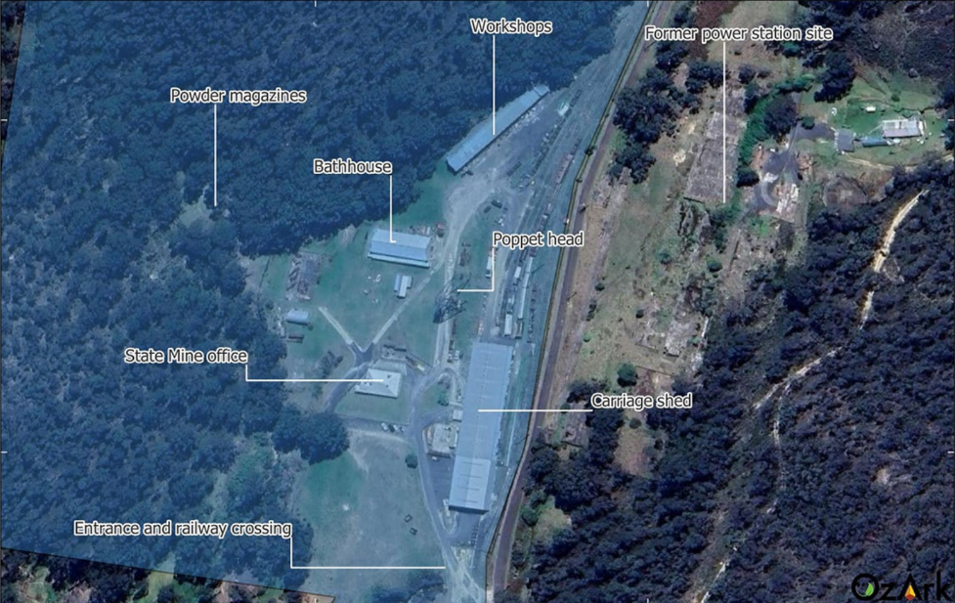  Along the trails; four features of potential heritage significance were identified during the survey. This includes: Steelworks Colliery, Dobbs Drift, Rock Shelter, and house ruins.  Minor excavation, rock armouring and track formation along the 1m track width are unlikely to encounter archaeological deposits and an unanticipated finds protocol is a suitable management strategy given the scale of the impacts and the potential heritage significance of any deposits.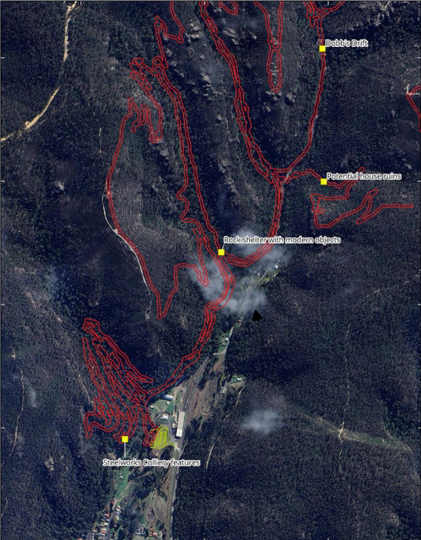  Management strategies are proposed to be implemented to avoid disturbance footprints to any historical relevance throughout the site. This includes 10m buffer restriction areas.
4.3.2. Design and Character | Objectives  O1. To promote high quality design that complements the existing streetscape character and heritage significance of the heritage item or heritage conservation area.  O2. To ensure that new developments will not adversely impact on the setting, streetscape character or views associated with any heritage item or heritage conservation area.  O3. To ensure that additions or changes to the external appearance of heritage items and contributory buildings respect the original, built form, architectural style and character. | The development being an open asphalt carpark, signage and amenities building will have no impact to the heritage buildings on the site. The location and setback of the proposal will not overshadow or visually impact the heritage items.  The development, although located at the front of the property, will not impact the streetscape, given that it involves minor building work, located on a grassed unformed carpark area, separated from the existing buildings onsite, and relatively small in scale. | Yes
4.3.3. Scale and Form | Objectives  O1. To ensure that alterations and additions to heritage items and contributory items are consistent with the scale and form of these items or buildings, and do not dominate or compete with the existing significant heritage fabric.  O2. To ensure that the scale and form of development is consistent with the predominant scale and form of the heritage conservation area, and of adjacent heritage items or contributory buildings. | Refer to the above comments. | Yes
4.3.4. Siting and Setbacks | Objectives  O1. To conserve and maintain established setbacks to streets.  O2. To ensure adequate curtilage and landscape setting for the building.  O3. To ensure the integrity of the heritage item and its setting, or the heritage conservation area, is retained by the careful siting of new buildings and alterations and additions to existing buildings. | Refer to the above comments. | Yes
4.3.5. Detailing | Objectives  O1. To ensure that original detailing is retained and kept in good repair.  O2. To encourage the reinstatement of original elements and detail.  O3. To ensure that alterations and additions and new development have a level of detail which is appropriate to the architectural character and style of the heritage item or heritage conservation area setting.  O4. To ensure that the pattern of door and window openings is clearly related to the placement, proportions and scale of existing fenestration of the heritage fabric. | Refer to the above comments. | Yes
4.3.6. Materials, Finishes and Colour Schemes | Objectives  O1. To ensure that the selection of materials and colours is informed by the original finishes and palettes match those used in the heritage item or heritage conservation area.  O2. To ensure that the visual quality of the heritage conservation area is maintained and upgraded by encouraging the use of appropriate colour schemes in all development | Refer to the above comments. | Yes
Chapter 8 – Rural & Other Land Uses
8.1.2 Overarching Objectives | Objectives  - Contribute to economic growth and employment opportunities within the LGA;  - Capitalise on existing development and maximise the efficient use of public infrastructure;  - Demonstrate good site planning, layout, functionality and amenity for users.  4) Conserve and enhance the historic, architectural and aesthetic character of urban areas (particularly in relation to heritage items and heritage conservation areas);  5) Respond to, reinforce, and sensitively relate to the natural environment and avoid or minimise the impacts of natural hazards.  6) Reinforce, complement and enhance the desirable visual and landscape character of the street or the rural landscape setting.  7) Integrate with and transition to neighbouring zones/lots/buildings; and  8) Preserve neighbourhood amenity and safety. | - During construction and once operational, the development will contribute to employment opportunities and economic growth by increasing visitation to Lithgow and stimulating increased local spending across accommodation, hospitality, retail and tourism services. The construction and ongoing operation of the park will create jobs in areas such as trail building and maintenance, while supporting indirect employment through local contractors and service providers.  - The proposed development conserves and enhances the heritage values of the State Mine Heritage Park and scenic views of the State Mine Gully area, as well as connecting to other surrounding walking and tourism tracks/adventures.  - The development is well positioned with convenient access to the State Mine Heritage Park, the State Mine Gully Precinct, Newnes Plateau and the Lithgow township.  The bike trails have been designed to minimise and preserve biodiversity where possible.  - The heritage values of the site are preserved by positioning the development clear of the heritage buildings. The development would complement the site’s heritage values by introducing facilities that support and enhance its tourism appeal.  - The proposed development is sympathetic to the surrounding natural environment and seeks to avoid and minimise impacts of natural hazards through trail location, trail footprint and construction techniques; and  - The development has been designed to respond to the environmental characteristics of the area. The existing building on the State Mine Heritage Park will not be visually screened or impacted by the carpark, amenities or trails.  - The development is permissible in the zone and is compatible with the surrounding uses/environment.  - The amenity and safety of the neighbourhood will be preserved through the location of trails away from property boundaries and the installation of appropriate safety measures. | Yes

- Section 4.15(1)(a)(iiia) – Planning agreements under Section 7.4 of the EP&A Act

There are no planning agreements proposed in relation to this development.

However, Council’s section 7.12 Local Infrastructure Contributions Plan (2024-2026) applies to the development.

The estimated development cost is $7,212,858.00 (including GST) and a 1% levy applies.

Estimated cost of development | Levy applicable
$0 to $100,000 | 0%
$100,001 to $200,000 | 0.5%
$200,001 and over | 1%

As such, the following condition shall form part of the Development Consent:

Prior to the issue of a Construction Certificate the applicant shall pay to Council a Section 7.12 contribution of $72,128.58 in accordance with the Lithgow City Council Local Infrastructure Contributions Plan (Section 7.12) 2024-2026. It is advised that the level of contribution in this plan may be adjusted at the time of actual payment, in accordance with the provisions of the Lithgow City Council Local Infrastructure Contributions Plan (Section 7.12) 2024-2026.

- Section 4.15(1)(a)(iv) - Provisions of Regulations

Environmental Planning and Assessment Regulation 2021 (EP&A Regulation)

Clause 61 of the EP&A Regulation contains matters that must be taken into consideration by a consent authority in determining certain development applications. The matters listed in clause 61 are not relevant to this development application.

Clauses 62 (consideration of fire safety) and 64 (consent authority may require upgrade of buildings) of the EP&A Regulation relate to changes to existing buildings. As no changes are proposed to existing buildings as part of the development, clauses 62 and 64 are not relevant to this development application.

  - Section 4.15(1)(b) – significant Likely Impacts of Development

The likely impacts of the development, including environmental impacts on both the natural and built environments, and social and economic impacts in the locality must be considered. In this regard, potential impacts related to the proposal have been considered in response to SEPPs, LEP and DCP controls outlined above and the key Issues section below.

The consideration of impacts on the natural and built environments includes the following:

Head of Consideration | Comment
Context and setting | The proposal has been designed to ensure amenity impacts, including sightlines to adjacent dwellings and lots are minimised. The proposed car park and trail head is suitably located away from residential properties.  The proposed development will not have any privacy impacts on surrounding properties.  All trails have suitable setbacks from property boundaries to ensure that there is sufficient bushland separating trails from neighbouring properties to maintain privacy.  The proposed development is not expected to have acoustic impacts on surrounding properties due to the passive nature of the proposal, the distance from residences and dense vegetation barriers.
Access, traffic and parking | Vehicle access to the carpark and trail head is proposed via the existing driveway entrance into the State Mine Heritage Park and Museum. This access is considered to be satisfactory for the development in terms of site safety.  The slope of the driveway contains a maximum 5% grade. This is below the 25% grade as stated in the DCP.  The total width of the driveway is approximately 6.0m carriageway width with a 20m entrance/exit adjoining State Mine Gully Road. This complies with the minimum carriageway width.  A landscaping plan was submitted with the application and shows landscaping to be proposed around the carpark area.  Parking is proposed to be located towards the front section of the State Mine Heritage Park, on a reasonably flat section, that is currently grassed and utilised as an informal carpark.  Parking design complies with Council’s Engineering Guidelines.  The parking layout has been designed to minimise potential safety impacts around the site and enable adequate manoeuvring for vehicles to leave the site in a forward direction.  The carparking area is proposed to consist of 111 spaces, (including an accessible space, staff parking, and minivan parking), including pedestrian walkways and landscaping.  The number of car parking spaces to be provided for the development is considered satisfactory.
Public Domain | The development is proposed to be located within an established built and environmental area. The development is expected to improve the public domain by providing additional facilities to the existing landscape.
Utilities | Water, sewer, electricity and telecommunication utilities will be provided to the development to the requirements of the relevant public utility authority.
Water/air/soil impacts | Water impacts have been assessed by WaterNSW and is found to be adequate for the development subject to conditions on the consent.  The development, once operational will have no impact on air quality. Conditions relating to dust will be conditioned on the consent during construction work.  The applicant has demonstrated through design plans, how the proposed development complies with the earthwork requirements including the need for potential batters.  The proposed development will have minimal impacts on drainage patterns and soil stability in the locality through construction in accordance with the stormwater management plan.  Conditions of consent are proposed to ensure dust and noise impacts are minimised during works and in perpetuity as a result of the earthworks. Additionally, conditions will be placed on the consent to control erosion and sedimentation impacts .
Noise and vibration | Noise is expected during construction of the development and standard conditions of consent are proposed to restrict construction hours.  Noise levels during operation hours, sunrise to sunset, are expected to be low due to the nature and location of the development.  Noise will be mitigated via the Operations Management Plan, that will be conditioned on the consent.
Natural Environment | The mountain bike park has been intentionally designed to integrate with and protect the natural environment, concentrating all built elements such as the carpark and amenities, within an already developed area of the Lithgow State Mine Heritage Park. By locating infrastructure in this existing footprint, the proposal avoids unnecessary clearing, preserves surrounding vegetation and landform, and maintains the ecological character of the broader landscape.
Social and Economic Impact | The Lithgow Mountain Bike Park will deliver a ‘world-class’ 25km network of mountain bike trails at State Mine Gully to establish Lithgow as a mountain bike destination while delivering clear economic, social and community benefits to the region.  The development would provide an additional recreational opportunity to the area as well as connecting infrastructure to the Gardens of Stone Conservation Area and to the State Mine Heritage Museum.  The mountain bike park will be accessible year-round, with amenities including water and toilets.  Therefore, the development is expected to provide additional employment (during construction and once operational) and tourism.  The development is within proximity to Lithgow’s CBD where direct transport links (road and rail) to Sydney, are the key elements that set the Lithgow Mountain Bike Park apart from other tracks.  The Statement of Environmental Effect states that the project outcomes include:  — Support from First Nations community demonstrated through their participation in the construction process and signage design.  — New regional jobs created as a direct result of industry growth.  — The Lithgow Mountain Bike Trail Park becomes a benchmark destination in NSW.  — A world-class mountain bike trail park is developed with supporting infrastructure including amenities for park users.  — A strategically located world-class mountain bike trail park located in prime position within walking distance of the Lithgow CBD and public transport nodes.  — Increased visitor numbers to Lithgow and the broader region year-round.  — Increased tourism related jobs.  — Increased patronage of the Lithgow State Mine Heritage and Railway Centre.  — The region becomes more attractive to businesses and investors.  — New opportunities for jobs and volunteering linked to the Park.  — Population numbers stabilise and growth accelerates in the Lithgow region.  — Residents are encouraged to remain in the region.  — Potential new residents consider the region as a place for them to live and invest.  — Recreational infrastructure developed that fosters community resilience, cohesion, connection and wellbeing.  — Provide a place where strong and sustainable community networks are created.  — Provide recreational infrastructure which enables residents and visitors to interact, engage and collaborate.  — Competitions and hosting of regional/national/state events year-round.  — Lithgow Mountain Bike Trail Park becomes a beacon for those seeking new recreational activities.  — World-class, low maintenance Mountain Bike Trail Park is built with longevity in mind.  — Use of sustainable materials during construction minimising impact on the environment and helping to meet net zero targets.  — All significant vegetation is being retained in place during construction to minimise impact on the environment and help meet net zero targets.  — Heritage and environmental assessments are undertaken as part of the project’s development, ensuring the integrity of the site and helping to meet net zero targets.  — Engagement of local suppliers and workers where possible minimising travel to and from the site, thereby helping to meet net zero targets.  — Appropriate facilities and amenities are provided to limit the risk of people polluting the area and damaging the environment.  As such, Council concurs with the above outcomes as having a social and beneficial impact to the area.
Natural hazards | The site is affected by bushfire, with the Rural Fire Service satisfied with the development subject to conditions on the consent.  A bushfire assessment report was submitted with the application in accordance with Planning for Bushfire Protection. The following measures were identified:  o A Bush Fire Emergency Management and Evacuation Plan (BFEMEP) is to be prepared as part of the development.  o limiting park access to manage risk.  o The facility will not operate on Catastrophic or Extreme Fire Danger Rating Days.  o Evacuation is the preferred course of action given the absence of assets to protect as part of the development. No requirement for provision of water supply was deemed required for the proposed development.
Safety, security and crime prevention | The development proposes sufficient security measures around the site; such as visual and geographical barriers, fencing, landscaping and alarms. An Operational Management Plan will also be conditioned on the consent to address safety and security.
Aboriginal Cultural Heritage | An Aboriginal Cultural Heritage Due Diligence Assessment has been prepared and is submitted with the DA.  The Assessment identifies:  — The Aboriginal Heritage Information Management System has a record for one Aboriginal site that plots within the study area, a rock shelter with artefact deposit registered as State Mine Creek.  — One Aboriginal site was identified during the visual inspection: State Mine Heritage Park Shelter.  — Five areas of archaeological sensitivity were identified: State Mine Heritage Park and Shelters.  The proposed works are limited to the ground surface, therefore, no Aboriginal objects or archaeological deposits are expected to be harmed. Should any objects be found during the construction and excavation works, mitigation and management strategies will be incorporated as conditions of consent should the application be approved.
Biodiversity | The Biodiversity Development Assessment Report identifies the proposal would occupy up to 2.92ha, of which 2.36ha possesses remnant native vegetation. The proposal triggers entry into the NSW Biodiversity Offsets Scheme under the NSW Biodiversity Conservation Act 2016 by virtue of exceeding the maximum allowable clearing threshold for the relevant lots and by impacting areas included in the Biodiversity Values Map.  The report details the proponent’s biodiversity offset requirement (measured by the number of ecosystem and species credits). These offset credit requirements are shown in the table below:  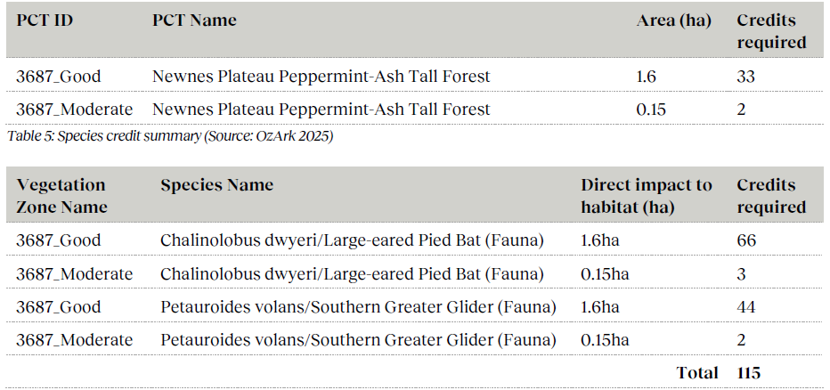  Offsetting is required for the 35 ecosystem credits and 115 species credits listed above.  The BDAR identifies that the following avoidance measures have been integrated into the design and/or are suggested for the implementation of the project:  — The proposed track width has been minimised by adopting, where possible, manual rather than machine-based methods of construction. This has reduced the overall anticipated impact from 4.60 ha of native vegetation (assuming a 2 m clearing width across the full alignment) to 2.36 ha, a reduction of >50%.  — The proposed alignment has been designed to make use of bare or sparsely vegetated rock where possible, reducing direct impacts to native vegetation. This particularly applies to PCT 3862 and parts of PCT 3688.  — Trees above 10 cm dbh will be retained, which includes all hollow-bearing trees within or near the proposed alignment.  — The proposed alignment adopts existing trails where these exist. Little or no additional construction is required in these areas.  — Where practical, the proposal would avoid direct impacts to stream beds by constructing bridges across 1st and 2nd order watercourses.  — In addition, minimisation and mitigation methods will be implemented as outlined in Table 6-3 of the BDAR.

  - Section 4.15(1)(c) - Suitability of the site

The site is considered suitable for a Recreation Area (Mountain Bike Park) for the following reasons:

- The development is both permissible within the C3 Environmental Management zone and consistent with the zone’s objectives, which encourages low-impact recreation that responds to environmental and landscape values.
- A comprehensive assessment has been undertaken, addressing key site constraints including bushfire risk, potential contamination water quality protection, traffic generation, access and parking arrangements, and potential impacts on adjoining properties. Eavh of these matters has been evaluated through the application and supporting studies, and all impacts have been determined to be low and capable of being effectively management through standard conditions of consent.
- Collectively, this demonstrates that the site can accommodate the proposed mountain bike park in a safe, environmentally responsible and context-appropriate manner.

The site is not subject to any other known risks or hazards that would render it unsuitable for the proposed development.

  - Section 4.15(1)(d) - Public Submissions

These submissions are considered in Section 4 of this report.

  - Section 4.15(1)(e) - Public interest

The development is considered to be in the public interest and is likely to result in an increase in tourism and traffic to the area. The development would further provide employment and economic benefits.

- REFERRALS AND SUBMISSIONS

  - Agency Referrals and Concurrence

The development application has been referred to various agencies for comment/concurrence/referral as required by the EP&A Act and outlined below in Table 3.

There are no outstanding issues arising from these concurrence and referral requirements subject to the imposition of the recommended conditions of consent being imposed.

Table 3: Concurrence and Referrals to agencies
Agency | Concurrence/  referral trigger | Comments  (Issue, resolution, conditions) | Resolved
Concurrence Requirements (s4.13 of EP&A Act)
Water NSW | Part 6.5 of the State Environmental Planning Policy (Biodiversity and Conservation) 2021  (Chapter 6 - Sydney Drinking  Water Catchment) | Water NSW considers that the proposed development can achieve a neutral or beneficial effect (NorBE) on water quality. Water NSW further provided appropriate conditions that are to be included in any development consent (18 December 2025). | Yes
Referral/Consultation Agencies
Rural Fire Service (RFS) | Section 4.14 of the Environmental Planning and Assessment Act 1979. | The development was referred to the Rural Fire Service seeking advice regarding bush fire protection. The New South Wales Rural Fire Service has objection to the application subject to recommended conditions be placed on the consent (27 November 2025). | Yes
Electricity supply authority | Section 2.48 – State Environmental Planning Policy (Transport and Infrastructure) 2021 Development near electrical infrastructure | Endeavour Energy has advised that the proposal is satisfactory subject to conditions. Refer to response received 6 November 2025. | Yes
Rail authority | Section 2.97 and 2.99 – State Environmental Planning Policy (Transport and Infrastructure) 2021  Development land that is in or adjacent to a rail corridor and excavation in, above, below or adjacent to rail corridors. | N/A | N/A
NSW National Parks and Wildlife Service | ‘Developments adjacent to National Parks and Wildlife Service lands | NSW Environment and Heritage Guidelines’, (DPIE-NPWS 2020). | The development was referred to NSW National Parks and Wildlife Service as an adjoining land owner. NSW National Parks and Wildlife Service has no objection to the application subject to recommended conditions be placed on the consent (25 November 2025). | Yes
Crown Lands | Section 2.23(5) Crown Land Management Act 2016 and clause 23 of the Environmental Planning and Assessment Regulation 2021 – consent of the Crown required | Crown Land has no objection to the application subject to recommended conditions being placed on the consent (25 November 2025). | Yes
Local Aboriginal Community | An Aboriginal Cultural Heritage Due Diligence Assessment was prepared and submitted with the application.  One recorded heritage site under Aboriginal Heritage Information Management System (AHIMS) was identified within the development locality.  As such, the development was referred to Local Aboriginal Parties for their input. | To date, no response from the Local Aboriginal community was received.  Given that the applicant consulted with interested parties prior to the lodgement of the application and an Aboriginal Heritage Assessment was undertaken, it is assumed that the Local Aboriginal Community has no objection to the application. | No
Local Aboriginal Land Council | An Aboriginal Cultural Heritage Due Diligence Assessment was prepared and submitted with the application.  One recorded heritage site under Aboriginal Heritage Information Management System (AHIMS) was identified within the development locality.  As such, the development was referred to Local Aboriginal Land Council for their input. | To date, no response from the Local Aboriginal Land Council was received.  Given that the applicant consulted with interested parties prior to the lodgement of the application and an Aboriginal Heritage Assessment was undertaken, it is predicted that the Aboriginal Land Council has no objection to the application. | No
Heritage NSW | As per Clause 5.10 Heritage Conservation, (7) Archaeological sites, the application as referred to Heritage NSW. | Heritage NSW concurs with the assessment provided that the proposed mountain bike trails will not impact the significant fabric within the State Mine Heritage Park, and that the any potential impacts to significant archaeological items is low. Heritage NSW supports the associated recommendations as documented within the conditions of consent should the application be approved. | Yes
Integrated Development (S 4.46 of the EP&A Act)
Subsidence Advisory | Section 22 – Coal Mine Compensation Act 2017 requires approval for development within mine subsidence districts. | Subsidence Advisory has considered the information submitted. General Terms of Approval, under Section 4.47 of the Environmental Planning and Assessment Act 1979, under section Clause 22 – Coal Mine Compensation Act 2017 (26 November 2025). | Yes
Department of Climate Change, Energy, Environment and Water (DCCEEW)-Water Group | S89-91 – Water Management Act 2000  Development requiring approval under Part 3 of Chapter 3 for a water use approval, water management work approval or activity approval. | The Department has provided General Terms of Approval (GTA) for part of the proposed development requiring a Controlled Activity approval under the Water Management Act 2000. | Yes

  - Council Officer Referrals

The development application has been referred to various Council officers for technical review as outlined Table 4.

Table 4: Consideration of Council Referrals
Officer | Comments | Resolved
Engineering | Council’s Engineering Officer reviewed the submitted Traffic and Parking Impact Assessment and considered that there were no objections subject to conditions. Response received 2 December 2025. | Yes  (conditions)
Building | Council’s Building Officer reviewed the submitted documentation and considered that there were no objections subject to standard conditions. Response received 21 January 2026. | Yes  (conditions)
Environmental | Council’s Natural Area Management Officer reviewed the submitted Biodiversity Development Assessment Report and considered that there were no objections subject to conditions. Response received 2 April 2026. | Yes  (conditions)
Water and Wastewater | Council’s Water and Wastewater Officer reviewed the submitted stormwater concept plan and considered that there were no objections subject to conditions. Response received 9 January 2026. | Yes  (conditions)
Property Officer | Council’s Property Officer reviewed the submitted plan and considered that there were no objections subject to conditions. Response received 25 November 2025. | Yes  (conditions)

  - Community Consultation

The development was publicly notified in accordance with the Lithgow Community Participation Plan 2020. The notification included the following:

- Notification letters sent to adjoining and adjacent properties.
- Notification on Council’s website.

During the notification period Council received a total of 26 unique submissions, comprising fourteen (14) objections and twelve (12, including one petition with 447 signatures) in favour of the proposal

All submissions (with redacted names) were sent to the applicant for comment regarding the concerns raised.

The issues raised in these submissions are considered in the Table below:

Table 5: Community Submissions

OBJECTIONS
Community Concern | Applicants Comments | Council Comments
Carpark Design  Design of the carpark and trail head will consume too much funding, recommend that a simpler design could be achieved. | The car park design is fully funded and will provide an excellent outcome including a new entry point for the museum. The overflow parking plan has been carefully considered and incorporated into the Operational Plan of Management for the trails and signage shall clearly direct any overflow to the required location.  Overflow to other areas shall be managed in consultation with Lithgow City Council. It is not expected that unfavorable overflow parking outcomes will establish themselves.  Macauley Street is not in the plan for any overflow parking or alternate entry point to the trails. | The car park has been located in proximity to the entrance and in association with the museum.  The design has been made to accommodate potential traffic volumes as well as providing facilities. The modern material will be incorporated into the heritage significant buildings with landscaping to provide a visual attraction to the site.  The design of the carpark is considered suitable for the development site, topography and environment.
Safety  - To ensure the safety of visitors and to prevent accidental or deliberate trespass/insurance claims, it is requested that the developer construct a secure boundary fence along the full length of the shared boundary, clear signage, prevention measures and ongoing maintenance.  - Use of the track should be restricted to daylight hours to prevent antisocial behavior and vandalism. | Visual and geographical barriers has been allowed for in the project budget.  The trails shall have dual entries, one on NPWS estate at Lost City and one at State Mine Heritage museum.  NSW police have requested that the Development Application (DA) include a Crime Prevention by Environmental Design Report which has been developed for the trails which has been completed and sent to NSW Police as part of the DA process. | Visual and geographical barriers are proposed to be constructed around the shared boundaries of residential properties.  Signage and management measures are further proposed to be undertaken.  The applicant has submitted a Crime Prevention by Environmental Design Report that was referred to the NSW Police as part of the assessment of the application.  The report addresses the following:  - Surveillance – The development would create on-going visitation to the area with the main entrance visible from State Mine Gully Road. The carpark and amenities building would further contain lighting and landscaping to minimise anti social behaviour.  - Access Control – existing and proposed site fencing will remain and be installed around the site boundaries that contains the museum. Signage will be installed around the site reinforcing times that the park would be managed.  - Territory Reinforcement – A Management Committee will be responsible for the overall management and operations of the park. A coffee/food van and shuttle bus are proposed for the site that will help with safety to the site. Regular safety audits will be undertaken by committee members specifically after large storm events to ensure the safety of the tracks.  - Space Management – Maintenance of the trails would be undertaken by committee members for the site.  The above management strategies is expected to limit the impact of vandalism and anti social behaviours.
Privacy  Tracks are close to the boundary which will represent a loss of privacy. Concerns relating to lookout points or elevated trails will not overlook rear yards compromising privacy. | The project team shall work closely with local residents to ensure that acceptable outcomes are achieved by protecting privacy of the neighbours to the trails. | Suitable visual and geographical barriers are proposed to be undertaken around residential boundaries of the site.  It is anticipated that majority of the tracks would be surrounded by existing vegetation (bushland) and topography (rock formations) that would limit visual impacts to residential landowners. Higher elevated areas would further be at a great distance to not compromise immediate privacy impacts than that already exists from current look out points.
Signage  Adequate signage to the entry point be installed. | Signage has been extensively allowed for in the project budget and shall be installed within the trails and extensively at the car park and entry point. | Should the application be recommended for approval, requirements for signage and location would be conditioned on the consent.
Access  - Clarification as to whether Macauley Street is intended to be utilised as an entry point now or in the future. If not, it is recommended that it is clearly documented,  - Existing road conditions and surfaces are very, very poor with patches on patches on patches, no curbs or gutters, no storm water drains, no footpaths.  - Unauthorised Access to properties. | Macauley Street is not in the plan for an entry point to the trails.  The condition of the road is known to both the project team and Council. As this is a Council asset, maintenance of the road falls under Council’s responsibilities. | The access to the site is from State Mine Gully Road with no access proposed from Macaulay Street.  In relation to the condition of State Mine Gully Road, this is currently partially controlled and managed by Council as well as being owned by National Parks and Wildlife Service within the Newnes Plateau.  The shuttle buses would utilise a small section of the Council managed section of the road and therefore this would have minimal impact.  The additional traffic movements would not warrant curb and guttering, drains or footpaths as construction work would be drained to an onsite bio-retention basin.  A Traffic Impact Assessment was submitted with the application and recommended the following management strategies:  - Sight Distance Improvements: remove obstructions such as vegetation to improve visibility along curves.  - Advance Warning Systems: install signage, or road markings to alert drivers of upcoming visibility restrictions.  - Speed Management: implementing reduced speed limits, advisory speed signs, or speed-calming measures to minimise risks in areas with limited visibility.  - Enhanced Road Delineation: by using high-contrast lane markings, retroreflective pavement markers, and guideposts to improve driver awareness.  - Intersection & Curve Treatments: applying Chevron Alignment Markers (CAMs) to assist drivers in navigating tight corners safely.  To reduce safety impacts in the area and improve the future road conditions, should the application be recommended for approval, conditions would be included on the consent, that the applicant consult with Council to implement traffic controls along all roads in the vicinity.
Traffic Impacts | A traffic impact assessment has been completed as part of the DA documentation. While the condition of State Mine Gully Road was noted as poor, it should be recognized that even with the extreme number of heavy vehicles which have traversed the road in recent months including hundreds of trucks for the upgrade of the NPWS section of road, the road is holding up remarkably well.  Increased traffic is expected as a result of the development and safety and condition of the road shall be managed by Lithgow City Council. | The predicted traffic movements within the traffic assessment report is found to be satisfactory for the development.  The assessment calculated approximately 19 vehicle movements per day would be undertaken for the development.  The management strategies outlined in the assessment and as detailed in the above comment is considered suitable for the development and to reduce potential traffic impacts.  It is to be further noted that this road network is currently being utilised for access to the Glow Worm Trails, The Lost City, walking, 4wheel driving, motorbike riding and camping areas within the Newnes Platue.
Noise, Events and Operating Hours-impacts to residents | Events are not planned nor form part of this DA. Events shall require their own DA and noise issues shall be addressed in these applications by the applicant for the event DA.  Mountain biking by its nature is a relatively quiet activity and noise from mountain bikes is not expected to be an issue as has been found at other installations around Australia. | Events are not proposed as part of this application.  Given the surrounding vegetation, topography of the land and nature of the development, noise would be limited within the site.
Traffic, Parking and Overflow-Impacts on Macauley Street. |  | Refer to previous comments indicating that there would be no access or parking within Macualey Street. There is adequate carparking spaces proposed for the development and on the State Mine Museum site.
Stormwater, Erosion and Land Stability- Altered drainage patterns, increase runoff, cause erosion. | The trails have been designed by some of the best trail designers in the country. The design report attached to the DA details the construction methods to ensure proper drainage and land stability.  A detailed report of the trails design with respect to riparian corridors and erosion control has been produced by the project team. This includes detailed maps of ‘waterfront land’ and potential impacts on turbidity and drainage. The report and maps have been submitted to the Department of Climate Change Energy Environment and Water (DCCEEW) and the department shall issue conditions precedent to ‘Controlled Activity Approvals’ which are designed to protect the waterways as per the requirements of the NSW Water Management Act 2000. | A stormwater management plan and water quality assessment has been undertaken for the carpark area. The trails do not require stormwater assessment given that minimal vegetation will be removed.  All runoff from the proposed car park area is proposed to be directed to a bio-retention basin in the southwest corner.  The stormwater management has been assessed against the WaterNSW water quality guidelines and Norbe Assessment.  The development was referred to WaterNSW who has given concurrence subject to conditions on the consent.  The development was also assessed by Council’s Engineers who considers the development to have adequate drainage.
Maintenance Responsibilities- boundary fencing, signage, erosion controls, security measures etc. | Furthermore, the trails shall be operated by a management committee under a full set of operational, safety and emergency management plans ensuring safety standards, maintenance and operation protocols including emergency management are maintained throughout the life of the trails. | As stated by the applicant, maintenance responsibilities would be undertaken by a management committee.  This would be conditioned on the consent should the application be recommended for approval.  As previously stated, visual and geographical barriers, signage, erosion controls and security measures will be undertaken.
Insurance and Indemnity- private landowners. | Insurance must be taken out for the trails and it is intended that, a yet to be established management committee is the insured party. | Private Insurance arrangements is not a planning consideration. It is a private matter for the landowners and business operator.
Bushfire Risk and Evacuation Concerns- safety, road access, recommend that a detailed Bushfire Emergency Management Plan is undertaken. | A bushfire assessment report has been undertaken for this DA by a suitably qualified consultant. They concluded:  “On completion, the proposed development will ensure that the development is located in an area that has an acceptable bushfire hazard level. With the implementation of the recommendations, as outlined in Section 4 and as shown on Figure 13, the proposed development is considered to be appropriately protected from bushfire and complies with the requirements of PBP. The proposed development is not expected to increase the bushfire risk.”  These recommendations included development of a Bush Fire Emergency Management and Evacuation Plan prior to operation of the trails. | A Bushfire Emergency Management Plan would be conditioned on the consent should the application be approved.  The application has been assessed by a bushfire consultant and the NSW Rural Fire Service.
Property Value and Amenity/Visual Impacts | It is intended that the trails shall not be visible from properties. It is well documented at successful facilities around the country that properties proximate to these types of installations do not have a negative effect on property prices, rather, their proximate location provides price increases and other opportunities to property owners.  Furthermore, once the construction works has revegetated, a 600 – 800mm trail will be all that remains visible and will be hard to distinguish in the dense bushland surrounding State Mine Gully. | Property values is not a planning consideration.  As previously discussed visual impacts would be reduced due to the existing landscape, topography and proposed visual and geographical barriers around residential boundaries that adjoin the site.
Biodiversity  - The proposal should avoid creating or enlarging trails on pagodas and in rock plate heath. These are rare landscapes that often support threatened flora in situations where harm is readily done even by a minimum width MTB track.  - The proposed Shared Track should use the existing 4WD track on the ridge east of State Mine Gully. This will reduce environmental damage and also provides more shade for those using the bike track.  - Any MTB should be limited to daylight hours. Riding at night, even with good bike lights, significantly increases the risk of collisions with native fauna, including threatened species, and can also disrupt fauna ecology due to a mix of noise, movement and lighting.  - The DA presents an opportunity to better address existing weeds through a VMP/WMP. The instrument should include biosecurity protocols to prevent existing weeds being spread and new weeds introduced and spread.  - Any biodiversity offsets that might be proposed should be assessed cautiously as to whether they are genuinely like-for-like and also genuine offsets i.e. would the proposed offset area have been at real risk from lawful damage prior to being proposed for protection or would it have been largely or entirely unharmed irrespective of the offset proposal.  - This DA puts the unique pagoda sandstone formations at risk. It also puts at risk the unique heath ecosystem, which supports many rare plants. This is a delicate landscape that does not regenerate easily. The rock is easily damage, soils erode easily and bikes will introduce weeds to the area.  - Scenic and Tourism Impacts- protection of scenic assets during construction and operation,  - Pagoda Impacts- Permanent visual scarring and physical damage to globally rare rock features, introducing weeds and excess nutrients,  - Impacts on Newnes- Rarity, sensitivity, conservation status, inadequate biodiversity assessment as it does not include offsets or protection measures,  - Flawed shared walking track proposal- The proposed route ascends an eastern spur across extensive tracts of sensitive Newnes Plateau Rockplate Heath will result in unnecessary landscape scarring.  - Inadequate Flora Assessment,  - Existing tracks have previously been abandoned and unrehabilitated. These tracks should be reused.  - Cumulative Impacts- biodiversity.  - EPBC Referral required.  - Incorrect/deficient assessment of threatened flora species-survey detection with specific species identified within the submission  - Purple Copper Butterfly Impacts, |  | A Biodiversity Development Assessment Report was submitted with the development application. The assessment was undertaken by a qualified consultant and reviewed by Council’s Natural Area Management Officer.  The proposed trails would utilise existing trails were possible to limit and avoid potential impacts to pagodas and rock plate heath. The assessment identifies sandstone pagodas to be adjacent to but not within the development footprint. The report also identifies the scale of impacts to the rock plate heath community to be minimal.  The hours of operation and management of the site including safety has been addressed earlier in this report. It is expected that limited riding would be undertaken during night time periods, due to the topography of the land and safety concerns.  Management of biosecurity protocols has been addressed within the Biodiversity Assessment Report and implemented where possible. This would be conditioned on the consent should the application be recommended for approval.  Biodiversity offsets has been assessed within the Biodiversity Assessment Report and conditioned on the consent should the application be recommended for approval.  An Operational Management Plan would be developed and conditioned on the consent to ensure construction and operations are undertaken with the development application.  As such, the Biodiversity Development Assessment Report was found to be adequate for the development and satisfies the Biodiversity Conservation Act 2016 requirements.
Aboriginal Heritage | An Aboriginal Cultural Heritage (ACH) Due Diligence Assessment has been completed for the DA and the entire length of the trails has been inspected by a qualified ACH archeologist.  It is intended to use the local community through the construction works to assist with the construction and ensure that no harm is caused to ACH during these works. | An Aboriginal Cultural Heritage Due Diligence Assessment was prepared and submitted with the application.  One recorded heritage site under Aboriginal Heritage Information Management System (AHIMS) was identified within the development locality.  Visual inspections of the site identified five areas of archaeological sensitivity; State Mine Heritage Park and State Mine Heritage Park Shelters with Artefacts.  Trails have been designed and located to avoid any known aboriginal heritage relics or sites of significance.  Therefore, it is concluded that the proposed works will have no impact to Aboriginal objects or archaeological deposits given that the proposed works will impact ground surface.  The assessment includes recommendations and management measures to protect Aboriginal cultural values. The Aboriginal Due Diligence Assessment Report (including the recommendations in the report) would be conditioned on the consent as a supporting documentation to the DA should the application be approved.

SUPPORT
- Community and Youth Benefits-safe, positive outdoor activities.

- Encourages connection, teamwork, promotes healthy and active recreational benefits.

- Positive Local Economic Impacts- Visitor/tourism attraction/benefits.

- A shared vision for Lithgow’s future.

- KEY ISSUES
The following key issues are relevant to the assessment of this application having considered the relevant planning controls and the proposal in detail:

  - Safety/Security

The development proposes visual and geographical barriers and security around the boundaries of the site. The facility will further be managed and maintained by staff. An Operational Management Plan will be conditioned on the consent to manage potential safety concerns. As such, it is considered the development satisfies potential safety concerns.

  - Noise

Noise is expected during the construction of the development with standard conditions of consent restricting to hours.

Noise during operational hours is not expected to be high volumes due to the nature and purpose of the development.

Noise will be mitigated via the Operations Management Plan, that will be conditioned on the consent.

  - Privacy

Suitable visual and geographical barriers is proposed to be undertaken around residential boundaries of the site.

It is anticipated that majority of the tracks would be surrounded by existing vegetation (bushland) and topography (rock formations) that would limit visual impacts to residential landowners. Higher elevated areas would further be at a great distance to not compromise immediate privacy impacts than that already exists from current look out points.
  - Traffic Impacts

The predicted traffic movements within the traffic assessment report is found to be satisfactory for the development.

The assessment calculated approximately 19 vehicle movements per day would be undertaken for the development.

The management strategies outlined in the assessment is considered suitable for the development and to reduce potential traffic impacts.

It is to be further noted that this road network is currently being utilised for access to the Glow Worm Trails, The Lost City, walking, 4wheel driving, motorbike riding and camping areas within the Newnes Plateau.
The access will further be undertaken in accordance with Council’s Engineering Guidelines.

  - Biodiversity

A Biodiversity Assessment Report has been undertaken for the development. The report identifies the proposal to occupy an area of 2.92ha which 2.36ha possesses native vegetation.

The native vegetation present in the disturbance footprint consists of four Plant Community Types
(PCTs):
- 3687 – Newnes Plateau Peppermint-Ash Tall Forest.
- 3688 – Newnes Plateau Silvertop Ash Woodland.
- 3696 – Western Blue Mountains Rocky Scribbly Gum Woodland.
- 3862 – Newnes Plateau Rockplate Heath.
22 Species were assumed present as ecosystem credit species, generating a total of 35 ecosystem credits. Five species credit species considered to be at risk of a Serious and Irreversible Impact. One species – the Swift Parrot could be excluded from consideration as the site does not fall within the area mapped as important habitat for the species. Three further species were eliminated by targeted surveys. The Large-eared Pied Bat was detected during targeted surveys and is considered present for the purposes of determining offsets. One additional non-SAII species – the Southern Greater Glider – was detected during surveys and was added to the offset calculations for the proposal. These two species would generate a total of 115 species credits, comprising 69 credits for the Large-eared Pied Bat and 46 credits for the Southern Greater Glider.

The proponent intends to purchase and retire the necessary number of credits on the open market or, if not available, offset credits through a direct payment into the Biodiversity Conservation Fund.

This would be conditioned on the consent should the application be recommended for approval.
- CONCLUSION

This development application has been considered in accordance with the requirements of the EP&A Act and the Regulations as outlined in this report. Following a thorough assessment of the relevant planning controls, issues raised in submissions and the key issues identified in this report, it is considered that the application can be supported.

It is considered that the key issues outlined in the report have been resolved satisfactorily through amendments to the proposal and/or in the recommended draft conditions in Attachment A.

- RECOMMENDATION

That the Development Application DA170/25 for a Recreation Area (Mountain Bike Park) at:

- Lot 1 DP965231, Coalbrook Street, Lithgow NSW 2790
- Lots 1, 2 & 3 DP1110346, Macaulay Street, Lithgow NSW 2790
- Lot 2 DP 787403 & Lot 11 DP1240259, 3A State Mine Gully Road, Lithgow NSW 2790
- Lot 10 DP1240259, 3 State Mine Gully Road, Lithgow NSW 2790
- Lot 2 DP876025, Atkinson Street, Morts Estate NSW 2790
be APPROVED pursuant to Section 4.16(1)(a) of the Environmental Planning and Assessment Act 1979 subject to the draft conditions to this report at Attachment A.

The following attachments are provided:

- Attachment A: Draft Conditions of consent
- Attachment B: Aboriginal Due Diligence Assessment Report
- Attachment C: Biodiversity Development Assessment Report
- Attachment D: Bushfire Assessment Report
- Attachment E: Contamination Report
- Attachment F: Detailed Design Report
- Attachment G: Geotechnical and Mine Subsidence Assessment
- Attachment H: Carpark and Trailhead Concept
- Attachment I: Operational Plan of Management
- Attachment J: Public Amenities Design Plans
- Attachment K: Civil Design Plans
- Attachment L: Site Survey Plans-Existing
- Attachment M: Site Survey Plans-Proposed
- Attachment N: Statement of Environmental Effects
- Attachment O: Statement of Heritage Impact
- Attachment P: Stormwater Management Plan
- Attachment Q: Traffic Impact and Parking Assessment Study
- Attachment R: Site Photos
- Attachment S: Analysis and Testing Report State Mine Creek locations
- Attachment T: Water Overlay Maps
- Attachment U: Crime Prevention Report
- Attachment V: Subsidence Advisory Approved Plans
- Attachment W: Department Climate Change, Energy, the Environment and Water – Water Group Response to RFI

